

1.0.0.0

**Measuresoft Development Ltd.**

***SNET to USB Interface 35954U User Manual***

**Version: 1.2.0.0**

**measuresoft development limited**

**partnership courtyard**

**the ramparts**

**dundalk**

**ireland**

**tel + 353 42 933 2399**

**fax + 353 42 932 7187**

This document is the copyright of Measuresoft, and may not be modified, copied, or distributed in any form whatsoever without the prior permission of Measuresoft

**prepared for measuresoft by**

**Ryan Craven**

**Tuesday, September 24, 2019**

**© measuresoft development**

**Technical Specifications 3595 4U IMP Interface**

**Inputs:**

Power requirement: 24-48Vdc External Power Supply

Power connection: Panel mounted 9 pin D sub plug

**Outputs:**

Output: SNET IMP power supply - serial communication network.

Output connection: Panel mounted 9 pin D sub socket.

Panel mounted USB "B" connection

**Network Cable Details:**

Cable Spec: Screened single pair cable 100Ohm impedance. 12-24AWG depending on network = length/number of IMPs

Maximum No IMPs: 50

**Operating Conditions :**

Temperature range: -20 to +50C

Relative humidity:(0 to 40C) <90%

**Mechanical:**

Casing: Aluminium sealed to IP55

Size (w x d x h) 170 x 116 x 36mm

Weight: 2kg

**Accessories:**

•USB Cable

•SNET network terminator on interface unit

•24-48VDC power supply (not included)

# Part 1

## Chapter 1- Introduction to 35954U Interface

### THE INTERFACE

The 35954U Interface is operable with any host computer that is fitted with a USB compatible interface. The Interface allows the host to communicate with a maximum of 50 IMPs via an S-Net cable.

The Interface provides all the hardware, timing control, error checking and data protocol necessary for reliable communication between the host computer and the S-Net system.

#### The 35954U Interface

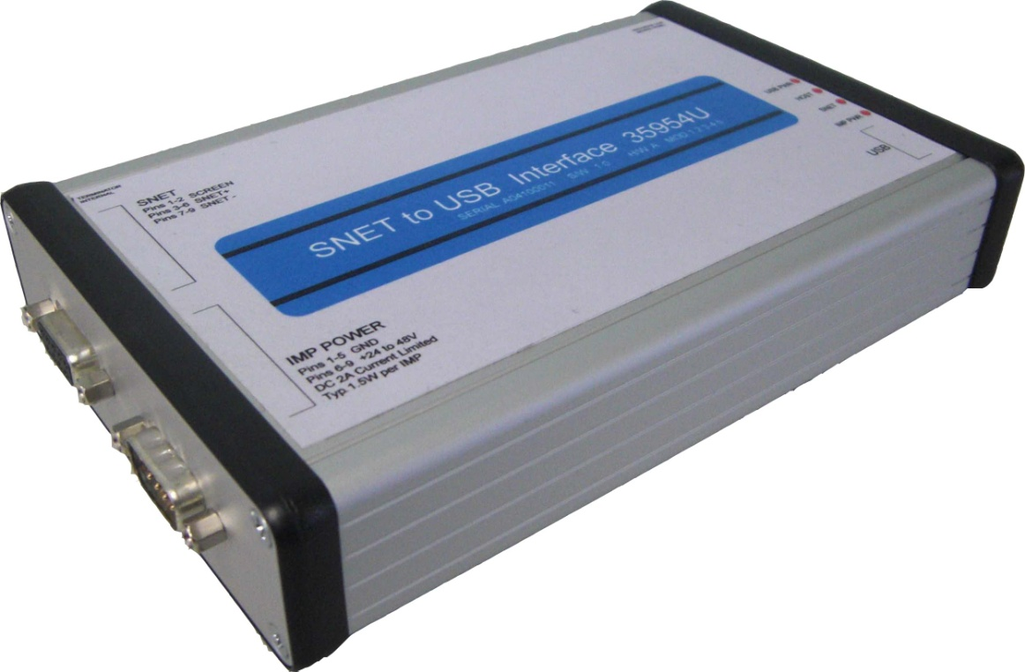

#### Front Panel

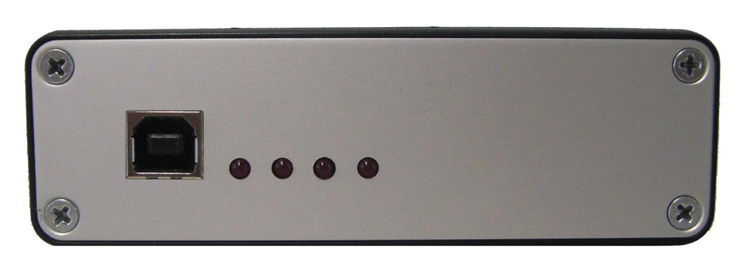

#### Rear Panel

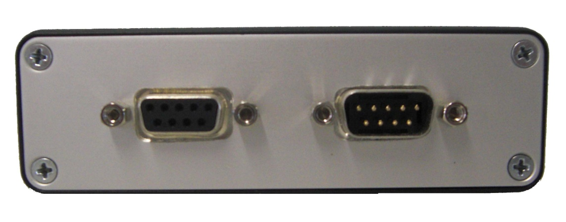

### THE MANUAL

This manual explains how to install and operate the 35954U Interface.

**Part 1** of the manual relates to the Interface itself:

**Chapter 1** Introduces the various facilities of the 35954U Interface

**Chapter 2** Relates to the installation of the 35954U Interface. Explains how to:

* Connect the Interface to IMPs, via S-Net,
* S-Net Termination
* Connect up an external power supply
* Connect to a PC

**Chapter 3** Details the cabling and power supplies required for your particular system

**Chapter 4** Describes the syntax, function and response of each of the Interface commands. The commands relate specifically to the 35954u Interface.

**Part 2** of the manual contains details of the IMP commands and responses.

**Chapter 1** Describes the syntax, function and response of each of the IMP commands.

**Chapter 2** Describes the format of the results and error messages received from the IMPs.

### DATA STREAMS

To categorise data the S-Net protocol operates four separate data types called streams. Each stream uses a different data format. This allows an application program to attach different priorities to data types and so to improve the speed with which high priority data (such as event timing) is handled. The steams are arranged as follows:

**Stream 0** Data in response to a command to measure all channels (a scan) or long numeric responses.

**Stream 1** Data in response to a command to measure one channel or short numeric responses.

**Stream 2** Event information.

**Stream 3** Character (ASCII) data, in response to some commands (status information or confirmations etc.).

### INTERFACE AND IMP COMMANDS

Commands are used in the form of ASCII character strings. For example, the RESET command is **RE.**

A command may be made more specific by using it with a number. For example, the command **CL2** means ‘clear event totalize counter on channel 2’. Multiple commands may be sent in strings to IMPs. They must be separated by semicolons. For example:

**ST;CL2**

A directory of Interface commands is presented in Part 1, Chapter 4, and a directory of IMP commands is given in Part 2, Chapter 1 of this manual.

## Chapter 2 – Interface Installation

This chapter outlines the installation of the 35954U Interface. It details how to:

* Connect the Interface to IMPs, via S-Net
* S-Net Termination
* Connect an external power supply
* Connect to a PC

### CONNECTING THE INTERFACE TO IMPS VIA S-NET

The 35954U Interface unit is connected to the S-Net via a 9-way female ‘D’ type connector on the rear panel of the unit (labeled ‘S-Net’). The connections to this are listed in Table 1.1 below.

#### Table 1.1 S-Net Connections

|  |  |
| --- | --- |
| **Pin** | **Function** |
| 1-2,6 | Screen |
| 3-5 | SNET+ |
| 7-9 | SNET- |

### S-NET TERMINATION

The IMPs, and S-Net Interface within the 35954U Interface, are high impedance devices, whilst the S-Net cable which interconnects them has a characteristic impedance of approximately 100Ω. Therefore, to avoid signal reflections, the S-Net cable must be correctly terminated at *both* ends.

The way in which the S-Net cable is terminated depends on where the 35954U Interface is placed in the S-Net system. An S-Net terminator is fitted in the Interface. A pair of terminators for use on the IMPs are supplied with the 35954U Interface.

Where the interface is placed at one end of the network (Fig 1.2) the terminator in the IMP Interface must be connected. A terminator should also be fitted to the IMP at the other end of the network.

#### Figure 1.1: The 35954U Interface placed at end of S-Net

IMP 1

IMP 2

IMP 3

IMP 4

CONTROLLER

IMP Interface Unit

To further IMPs if required

*



*

S-Net

USB

*S-Net terminators should be fitted to the IMP Interface and to the IMP at the end of the S-Net

Where the Interface is placed in the network (Fig. 1.2) the terminator in the 35954U Interface should be disconnected and the IMPs at either end of the network should each have a terminator fitted.

#### Figure 1.2: The 35954U Interface placed between IMPs on the S-Net

*S-Net terminators should be fitted to the IMPs at either end of the S-Net cable

S-Net

To further IMPs if required

IMP 1

IMP 2

IMP 3

*

*

To further IMPs if required

IMP Interface Unit

IMP 7

IMP 6

IMP 5

IMP 4

USB

CONTROLLER

#### 1.2.2.1 INSERTING OR REMOVING THE TERMINATOR JUMPER

The S-Net terminator within the 35954U Interface Unit is connected via an internal jumper. To disconnect the terminator you simply remove the jumper. The configurations which decide whether or not the terminator is to be connected are described on the previous page. The procedure for accessing the terminator jumper is as follows.

1. Remove and retain the 4 screws from the rear panel (where the S-Net and Power Connections are located) of the Interface.
2. With care, slowly slide out the panel. You do not need to remove the panel from the housing completely.
3. In the top right hand corner you will see the jumper (See Fig. 1.3 for assistance). To remove the jumper, simply lift it out of the PCB. The jumper should be retained for future use. To reinsert the jumper, push it firmly into the PCB.
4. Slide the panel back into the housing unit and with care, secure the 4 screws.

##### **Figure 1.3: Location of the terminator jumper on the main PCB of the 35954U Interface**

Terminator Jumper

S-Net

Power

### CONNECT EXTERNAL POWER SUPPLY

Where the power is supplied to the IMPs down the S-Net cable, this power may be generated either by the internal power supply of the 35954U Interface Unit or, where this is inadequate for the system in use, by an external supply. The external power supply is connected via a 9-way ‘D’ Type connector located at the rear of the unit. The connections to this are located in Table 1.2

#### Table 1.2 External Power Connections

|  |  |
| --- | --- |
| **Pin** | **Function** |
| 1-5 | GND |
| 6-9 | +24 to 48V |

The cable requirements for S-Net power, for either the internal or external power supply, are detailed in Chapter 3 as are the requirements for the external supply.

**Note:** When an external supply is used the 35954U Interface must still receive ac power to provide its own dc rails. Connection of the external supply automatically disconnects the internal supply from S-Net.

### CONNECT TO A PC

The 35954U Interface connects to a PC via a USB “B “cable. To install the Interface on your machine, follow the steps below for the appropriate operating system.

#### Windows XP

If you are installing the Interface for operation on Windows XP you will need to download and install the appropriate virtual COM port drivers. These drivers are available from [www.solartron-imp.com](http://www.solartron-imp.com), or from <http://www.ftdichip.com/Drivers/VCP.htm>.

When you have downloaded the drivers, please follow the steps below.

1. Ensure the 35954U Interface Unit is placed securely.
2. Download the virtual COM port drivers save it where you can access it easily
3. Connect the Interface to your machine using a USB “B” cable
4. When prompted, choose to install the drivers manually
5. Navigate to the folder you downloaded in Step 2 and click ok.
6. The drivers for the Interface will now be installed.
7. Once completed you should now see the Interface appear in your device manager under “Ports”

#### Windows Vista

1. Ensure the 35954U Interface Unit is placed securely.
2. Connect the Interface to your machine using a USB “B” cable
3. Windows Vista should automatically detect and install the drivers for the Interface. If not, please download the driver from our site, choose manual install, navigate to the downloaded file and click ok.
4. The drivers for the Interface will now be installed.
5. Once completed you should now see the Interface appear in your device manager under “Ports”

#### Windows 7

1. Ensure the 35954U Interface Unit is placed securely.
2. Connect the Interface to your machine using a USB “B” cable
3. Windows 7 should automatically detect and install the drivers for the Interface. If not, please download the driver from our site, choose manual install, navigate to the downloaded file and click ok.
4. The drivers for the Interface will now be installed.
5. Once completed you should now see the Interface appear in your device manager under “Ports”

## Chapter 3 – Cabling and Power Supplies

### S-NET CABLE

IMPs are linked to the 35954U Interface by S-Net, a serial communications network. The S-Net cable consists of a twisted par of multi-stranded wires with a screen around them and has a nominal characteristic impedance of 100Ω. Unscreened cables may be used, but in electrically hostile environments S-Net signals may be subject to interference. In most applications signals and IMP power a both delivered via the S-Net cable, which is connected to a D-type connector on the Interface. The connection details are given in Chapter 3.

Table 1.1 lists the cables selected as being particularly suitable for liking IMPs to the Interface. The cables are intended for general purpose use.

**Table 1.1: Cables recommended for S-Net**

|  |  |
| --- | --- |
| **Gage (single conductor)** | **Type** |
| AWG |  |
| 12 | Brand-Rex T12459 |
| 14* | Brand-Rex CD8920204 |
| 16 | Brand-Rex T12460, Alpha 9820, Belden 9860 |
| 18* | Brand-Rex CD8920251, Belden 9250 |
| 20 | Brand-Rex BC57207, Alpha 9818, Belden 9207, Belden 9815 (direct burial) |
| 24 | Brand- Rex BI56641, Alpha 2400, Belden 8641 |
| * The large diameter of these cables necessitates special consideration when making connections to the IMP. For details see the IMP Installation Guide. | |

Approximately 10 meters of 24 AWG Belden 8641 cable are provided with each module. This is sufficient for small data acquisition systems or for testing purposes. The connections are: S-NET + ve = black and S-Net – ve = white.

### POWER SUPPLY

Each IMP consumes approximately 1W (1.2W at power-up). (35951D Analogue output IMPs can, in some applications, require more. In these circumstances they need special consideration, refer to the 3595 Series IMP Installation Guide for details.)

IMPs may be supplied with power in one of three ways:

1. From the internal power supply of the Interface, via the S-Net cable. The internal power supply of the interface can provide 43V for the S-Net system.
2. From an external 43V-50V dc power supply connected to the external power plug on the Interface; again, via the S-Net cable. The location and the pin numbering of this external power plug are shown in Chapter 3, “Electrical Installation of the 35954U Interface”. This method allows up to 50 IMPs to be operated with a maximum cable length of 1km. See Section 4.3.2 (in present chapter), “Cable Selection When Using the Interface External Supply”.
3. Directly from a power supply, local to the IMP(s). For 3596 Intrinsically Safe IMPs this is the only method of providing power. For further information refer to the 3595 or 3596 Series IMP Installation Guides

#### 1.3.2.1 EXTERNAL POWER SUPPLY REQUIREMENTS

Operation is automatically switched to the external supply when a voltage over 43V is applied to the external power plug on the Interface.

An external power source must fulfil the following requirements:

1. Current limited to 3A-4A, or protected by a 4A fuse.
2. Voltage 43V-50V. This depends on the wire gage, the cable length and the number of IMPs connected to the cable.
3. Supply ripple less than 100m V rms.

It is permissible for a battery operated S-Net system to have a charger permanently connected. Batteries generally provide sufficient output smoothing.

It is important that external power supply is able to supply maximum current on short circuit without folding back. Foldback is performed by the 35954U unit itself.

A suitable supply is the 48V System PSU.

### CABLE SELECTION

Cable selection depends on two cable characteristics:

1. The a.c. attenuation of the cable. This affects the digital communications running back and forth along the cable, between the IMPs and the Interface. There are two specific points to consider:
   1. The high a.c. attenuation of the 24 AWG cable means that S-Nets using this cable cannot be longer than 660 meters.
   2. The low a.c. attenuation of the 14 and 18 AWG cables means that the S-Nets using these cables cane be extended up to 1.5km. The large diameter of these cables necessitates special consideration when making connections to the IMP. For details see the IMP Installation Guide.
2. The d.c. resistance of the cable. This, and the voltage of the power supply, determines the maximum number of IMPs that can be powered via the cable. Generally, if any IMPs on the network are powered from the Interface via the S-Net cable, it is important that a cable of adequate gage is used. The optimum cable size depends on the number of IMPs to be powered via the S-Net cable, the cable length required and the power supply voltage. Information on choosing the cable, either for power provided internally from the interface or from an external supply via the Interface, is given below.

#### 1.3.3.1 CABLE SELECTION WHEN USING THE INTERFACE INTERNAL SUPPLY

The internal power supply of the Interface can supply 43V to the S-Net system. For this, Table 4.2 shows the recommended maximum cable length, in metres, for a given gage of cable and number of IMPs.

##### **Table 1.1: Maximum Cable Lengths for IMPs Using the Interface Internal Supply**

|  |  |  |  |  |
| --- | --- | --- | --- | --- |
| **No. of IMPS** | **Maximum Cable Length (Metres)** | | | |
| **12 AWG**  (3.4mm2 ) | **16 AWG**  (1.3mm2 ) | **20 AWG**  (0.5mm2 ) | **24 AWG**  (0.2mm2 ) |
| 1 | 1000 | 1000 | 1000 | 660 |
| 2 | 1000 | 1000 | 1000 | 660 |
| 3 | 1000 | 1000 | 1000 | 660 |
| 4 | 1000 | 1000 | 1000 | 534 |
| 5 | 1000 | 1000 | 1000 | 427 |
| 6 | 1000 | 1000 | 900 | 356 |
| 7 | 1000 | 1000 | 772 | 305 |
| 8 | 1000 | 1000 | 675 | 267 |
| 9 | 1000 | 1000 | 600 | 237 |
| 10 | 1000 | 1000 | 540 | 213 |
| 11 | 1000 | 1000 | 491 | 194 |
| 12 | 1000 | 1000 | 450 | 178 |
| 13 | 1000 | 1000 | 415 | 164 |
| 14 | 1000 | 1000 | 384 | 151 |
| 15 | 1000 | 923 | 352 | 139 |
| 16 | 1000 | 841 | 321 | 127 |
| 17 | 1000 | 758 | 290 | 114 |
| 18 | 1000 | 676 | 258 | 102 |
| 19 | 1000 | 594 | 227 | 89 |
| 20 | 1000 | 512 | 196 | 77 |
| 21 | 933 | 430 | 164 | 65 |
| 22 | 755 | 348 | 133 | 52 |
| 23 | 577 | 266 | 101 | 40 |
| 24 | 400 | 184 | 70 | 27 |
| 25 | 222 | 102 | 39 | 15 |

#### 1.3.3.2 CABLE SELECTION WHEN USING THE INTERFACE EXTERNAL SUPPLY

When IMPs are powered from an external supply connected to the Interface it is possible to use longer lengths of S-Net cable than those listed in Table 4.2/ It is important, however, that the core of the cable is of an adequate gage. The actual gage required depends on the number of IMPs to be powered, their distribution along the cable and the power supply voltage.

To select a suitable wire gage and supply voltage for a given system, refer to the cable selection graph (Fig. 4.1). This graph assumes the worst case distribution of IMPs, i.e. all IMPS grouped at the far end of the cable, ad incorporate a safety factor.

##### **1.3.3.2.1 EXAMPLE OF THE USE OF THE CABLE SELECTION GRAPH**

Say, for example, that the supply voltage has been fixed at 50V and 10 IMPS are to be powered via the S-Net cable. The total cable length is expected to be around 400 metres. Refer to Fig. 4.1 and determine the point on the graph where ‘10 IMPs’ and ‘0.4km’ intersect; in this case, the 20 AWG region. This is the smallest gage cable that can be used. Therefore, the 20, 16 or 14 AWG cables are suitable.

###### **Fig. 3.1** Graph showing recommended minimum wire gage for 50V external supply (current limited to 3A with minimum voltage at IMP of 100V)

## Chapter 4 – Interface Commands

### INTRODUCTION

This chapter describes the commands that are used to control the 35954U Interface. The commands used to control the IMPs on the S-Net are described in Part 2 of the manual.

#### COMMAND STRINGS

The following rules apply to command strings:

1. Individual commands within a command string must be separated by semi-colons. Any number of commands may be strung together in this way. The commands are executed in order, left-to-right across the string, and the responses are returned in the same order.

2. Command strings must not contain unnecessary spaces, or lower case characters.

#### **COMMAND TYPES**

Command strings are built from three basic command types:

1. Interface Commands. Used only to control the 35954U and not routed to IMPs on the S-Net. These commands always start with “I_”

2. General IMP Commands. Applicable to most IMPs in the system.

3. Specific IMP Commands. Applicable only to a specific type of IMP. For example, the EV command applies only to the 35952A Digital IMP.

The IMP commands are detailed in Part 2 of the manual.

#### NUMBERS IN COMMANDS

The majority of commands require one or more numbers to further specify the command. For example, the I_IA command must be specified with an IMP address. Unless noted otherwise in the command directory, these numbers are ASCII (keyboard) characters and not numeric variables. For example: I_IA15.

Values for parameters such as gauge factors and offsets should be sent in ASCII decimal format or ASCII HEX IEEE format. The ASCII decimal values must be enclosed in single quotes and the ASCII hex must also be preceded with a dollar sign ($) or an ampersand (&), e.g.

‘-2.25’,’$40A00000’,’&40A00000’

**In the above example the ASCII hexadecimal numbers, i.e. ‘$40A00000’,’&40A00000’, are in the compressible format mentioned in Section 1.1.**

Binary information should be sent in ASCII Hex format, enclosed in single quotes, and preceded with “$“or “&”.

#### EXAMPLES OF COMMAND STRINGS

A command string, which consists of a sequence of two or more commands, can be sent by inserting semi-colons between individual commands. Each command is then executed, in turn, by the interface. Each complete transmission should not exceed 256 characters in length, including semi-colons.

Two examples of useful command sequences are:

(a) Fetch status from the IMP at address 5:

**I_IA05; ST; I_SR05312**

The first command contains the address of IMP5; the second command is a “Request Status” IMP command (sent by the interface to IMP5) and the third command reads the 12 character status from IMP 5, stream 3.

(b) Fetch data continuously from IMP-05:

**1_IA05; SE; CO; TR**

The first command sets the IMP address for communication with IMP 05.

The next two commands

(i) Set the IMP channels to either Volt dc auto ranging (analogue IMP) or digital status (digital IMP),

(ii) Enable continuous measurement

#### INCORRECT INTERFACE COMMANDS

Any commands received at the interface that do not start with an I_ are routed through to the S-Net. Therefore, it is possible to send an IMP a command which it is not capable of complying. This may have no noticeable effect if the command does not instruct an immediate response. A subsequent command to perform a measurement can then give an error message or an incorrect reading.

It is the responsibility of the application program to check that any commands sent are of the correct syntax and that the IMP or interface is capable of complying with them.

### INTERFACE COMMAND SUMMARY

The function of each interface command is summarised in Table 1.1. Details of the commands are given in Section 1.3.

#### Table 1.1 Interface Command Summary

|  |  |
| --- | --- |
| **Command** | **Purpose** |
| I_IAaa | Specifies the address of the IMP to be commanded |
| I_IN | Initializes the interface and applies power to S-Net |
| I_IP | Initializes the interface with a polling table and applies power to S-Net |
| I_PO | Shuts down the interface and switches off power to S-Net |
| I_PS | Returns the product serial number in hex |
| I_SRaasn | Reads a single data block from IMP aa stream s as ASCII. |
| I_TIDD-MM-YY hh:mm:ss.th | Loads the time and date |
| I_TI? | Requests a time readout |

### COMMAND DIRECTORY

In this directory the commands appear in alphabetical order.

Each command description is headed with the command code, and the command title in brackets, e.g.

**I_SR (Stream Read)**

The command syntax is shown by a flow diagram, which includes any command variables, e.g.

**I_SRaasn**

**aa** is the IMP address.

**s** is the stream number.

**n** is the number of S-Net bytes to be returned from stream “s” at IMP address “aa”

Note that command codes are shown in upper case characters and variables in lower case. Only the items in the box form part of the command string. A description of each command variable and its limits appears under the flow diagram, as shown above.

After the flow diagram the following information is given:

**Function:** Description of the command function.

**Response:** What the IMP transmits to the host in response to the command.

#### I_IAaa (Imp Address)

**I_IAaa**

**Function**: The Imp Address command specifies the address of the IMP that is to receive the IMP commands. This address remains in force until changed by another IMP address command. For normal operation, aa takes the values,

00 ≤ aa ≤ 50

To transmit to all IMPS, aa = 00: this is particularly useful for sending a broadcast trigger. The default setting for aa is 01.

**Response**: None

**NOTE**: A transmit error (S50) is not indicated should an IMP fail to receive a command transmitted to all IMPs, i.e. when aa = 00.

#### I_IN (Initialize)

**I_IN**

#### I_IP (Initialize with Poll Table)

**I_IP<0 or 1 for 50 Imps>**

**Function**: The Initialize command initializes the interface, which, in turn: initializes the S-Net.

The default set-up obtained on initialization is as follows:

1. Crystal-derived time synchronisation.
2. Terminator is Carriage Return/Line Feed for the Serial and USB ports.
3. The output to the other port is disabled, whilst the port receiving the INitialize remains enabled.
4. IMP address is set to 1.
5. Configured for all 50 IMP addresses.

**Response**: Initialize acknowledge. The acknowledge message contains the status and issue of the firmware in the interface. It has the format S01 status CX where C is the status and X is the issue. The acknowledgement is preceded by a sequence of three nulls and a terminator to terminate any line that the interface may be sending when the interface interprets the I_IN command.

#### I_PO (Power Off)

**I_IN**

**Function**: The Initialize command shuts down the interface, which, in turn: shuts down the S-Net.

**Response**: S00 Powered down.

#### I_PS (Product Serial Number)

**I_PS**

**Function**: The product serial number commands returns the product serial number in hex.

**Response**: S00 XXXXXXXXXXXXXXXX

#### I_SRaasn (Stream Read in Acsii, imp address, stream and bytes)

**I_SRaasn**

#### I_STaasn (Stream Test, imp address, stream)

**I_SRaas**

#### I_SBaasn (Stream Read in Binary, imp address, stream and bytes)

**I_SRaasn**

**Function**: The Stream commands instructs the interface to process a single block of data from IMP address *aa* and stream *s*. The parameter *n* specifies the number of S-Net bytes to be returned from this source.

The I_SR command returns twice the number of bytes requested returned by the interface, because of the output format used. Except for Stream 3, which uses alphanumeric ASCII characters only.

The I_SB can return up to twice the number of bytes requested as control characters in the range 0 to 0x1F are transmitted as 0x1F and 0x20+byte.

The ranges of the values that can be assigned to aa and s are as follows:

00 < aa ≤ 50

0 ≤ s ≤ 3

The value of n (see Table 5.2) depends on the stream and the application.

These commands are particularly useful for reading data from streams 2 and 3, since data in these streams is returned asynchronously. An appropriate single read can be put on each IMP and stream after initialization. On receipt of any data, no more data need be received until the interface has processed the present data and issued another single read.

**Response**: For stream test and ascsii read H<number of bytes>

The data is returned as specified or an error is returned for reception errors.

(See section on output formats)

#### I_TI (command TIme)

**I_TIDD-MM-YY hh:mm:ss.th**

**Function**: The “command TIme” command loads the time and date into the real-time clock/calendar of the interface.

DD = day (00-31), MM = month (00-12), YY year (00-99), hh = hour (00-24), ss = seconds (00-60), th = Tens and hundredths of seconds (00-99)

**Response**: None

#### I_TI? (command TIme request)

**I_TI?**

**Function:** The “command TIme request” command requests the interface to return the time and date.

**Response**: A message with the format:

**S00 DD-MM-YY hh:mm:ss.th**

where the parameters have the same meaning as in the **I_TI** command above.

If the time has not been set since either an I_IN command or since power up, then the response will be:

**S00 00-00-00 00:00:00.00**

### OUTPUT FORMATS

The blocks of ASCII data, known as messages, that are output from the Serial and USB ports of the interface may contain S-Net measurement/status data or interface error/status information. The first byte in a message identifies the message type.

S-Net measurement results from Streams 0, 1 and 2 are sent as HEX characters. Stream 3 data, which consists normally of ASCII characters, is sent as received. Error/status data from the interface consists of an error/status number plus additional information in accordance with the circumstances.

When data is requested from Streams 0, 1 and 2, twice the number of requested bytes are actually received. This is because the four-byte IEEE measurement data read from the IMPs are converted by the interface to eight-byte ASCII IEEE format. In fact, any byte received from these three streams is converted to the two-byte ASCII hex equivalent, e.g. “8AH” is converted to “38H, 65H” which are the ASCII codes for the characters ‘8’ and ‘A’.

The reason for this conversion is that the bytes sent by an IMP could, if relayed without conversion to the serial and USB ports, be misinterpreted as ASCII control characters, e.g. ODH (carriage return) and 3H (Xoff).

#### S-NET MEASUREMENT/STATUS FORMAT

The first line of the message contains the header identifier ‘H’, IMP address aa, and the stream number s. Subsequent lines contain the results, with each line containing up to eighty bytes (ten results).

**isaa < terminator(s)>**

**b0, b1, b2, b3, b4, b5, b6, b7...bn <terminator(s)>**

**b0, b1, b2, b3, b4, b5, b6, b7...bn <terminator(s)>**

where

**i = ‘H’ for header identifier**

**s = stream number**

**aa = ‘01’ to ‘50’ for IMP address**

**b0 - bn = bytes of(up to ten) results**

and the terminators depend on the port and the Set Interface command e.g.

**H101 <terminator(s)>**

**40A00000< terminator(s)>**

#### INTERFACE ERROR/STATUS FORMAT

The message consists of an identifier to indicate a status message and an error/status number which identifies the particular error or status information. Additional information may also be sent in the remaining bytes.

**innb0, b1, b2....bn <terminator(s)>**

where

**i =‘s’ for error/status**

**nn = ‘00’ to ‘49’ for status numbers  
or ‘50’ to ‘99’ for error numbers**

**b0 - bn = bytes of information depending on the error/status  
number.**

The terminators used depend on the port and the Set Interface command, e.g.

**S00dd-mm-yy hh:mm:ss.th <terminators>**

The data returned may contain time information, as in the above example, or the IMP address and stream information.

When using the ENQ/SOH protocol on the Serial port the complete response from the stream is terminated after the last byte with the ETX control character, e.g.

**H101 <terminator>**

**40A00000 <terminator(s)> ETX.**

### MESSAGES

Messages may be generated either as a result of errors at the IMP or the interface or in response to a valid command. These messages are presented on the current port, either USB, serial or both. The full complement of messages is contained in Tables 1.2 and 1.3.

For more information on the result and error formats refer to Part 2 of the manual.

#### Table 1.2 Responses to Valid Commands

|  |  |  |
| --- | --- | --- |
| **Displayed Message** | | **Comments** |
| **Number** | **Descriptive String** |
| S00 | DD-MM-YY HH:MM:SS. TH | Returned in response to I_TI? command |
| S01 | Status XY | Returned in response to I_IN command, X = status, Y = issue |

#### Table 1.3 Error Messages

|  |  |  |
| --- | --- | --- |
| **Displayed Message** | | **Comments** |
| **Number** | **Descriptive String** |
| S50 | XX | IMP command string fails to arrive at IMP XX |
| S51 | XXY | Requested data from stream Y of IMP XX is either corrupted during reception or nothing is received at all |
| S54 | S-Net command too long | A single S-Net command has been issued that contains more than 256 characters, after any numbers contained in the command have been converted. |
| S62 | Command string too long | This error is received when a command string of more than 256 characters is sent to the interface. When this happens the interface discards the entire command string |
| S70 | Invalid number | Some S-Net commands require the parameter values to be in IEEE format. Error S70 means that the IEEE format has not been used. |
| S71 | Invalid hexadecimal | This error is returned when an invalid ASCII hex number has been sent to the interface |
| S72 | Unknown internal command | The initial code of a command, e.g. I_XX, is not recognised. |
| S73 | Parameter error | Indicates an interface command with invalid parameters. |

# Part 2

## Chapter 1 – IMP Commands

### INTRODUCTION

This chapter provides information on the use of IMP commands, a summary of commands, a detailed command directory, and suggested command procedures.

#### COMMAND STRINGS

The following rules apply to command strings:

1. They must not contain more than 256 characters (bytes).
2. They may contain a number of individual commands, as long as they are separated by semicolons.
3. Commands are executed in order, left-to-right across the string, and responses are returned in order.
4. They must not contain unnecessary spaces or lower case characters.
5. If a command includes some binary-coded information, all bytes of this data must be included.
6. Omissions can cause both the command involved, and subsequent commands, to be misinterpreted.

#### IMP COMMAND TYPES

Command strings are built from two basic command types:

|  |  |
| --- | --- |
| General Command | * applicable to most IMP types |
| Specific Command | * applicable to a particular type of IMP. For example, the EV command applies only to the digital and switch IMP devices |

#### NUMBERS IN COMMANDS

The majority of commands require one or more numbers to further specify the command. For example the **ME** (measure) command must be specified with a channel number. Unless otherwise stated in the command directory, these numbers are ASCII (keyboard) characters and not numeric values.

#### EXAMPLES OF COMMAND STRINGS

A string of two or more commands may be sent by inserting semicolons between individual commands. On receipt of a command string, the IMP executes each command in turn, left-to-right. Each command string should not exceed 256 characters (bytes) in length, including semicolons.

As an example, the command sequence SE; TR provides a quick measurement set-up:

1. On an IMP *other* than the Universal IMP ‘1H and ‘1J, it selects ‘volts dc auto-ranging’ (for analogue versions) or ‘digital status’ (for digital and switch versions).
2. It arms the IMP to make measurements.
3. It tells the IMP to take a scan – that is, measure on all channels.

**Other useful command sequences are:**

1. **RE ; CHnMO103 ; MEn (For analogue IMP and Universal IMP)**

**This command resets previous settings; sets channel n to ‘volts dc 2V range’, and tells the IMP to take a measurement on channel n.**

**(On an IMP other than the UIMP, channel n can be any channel; on the UIMP, channel n can be any channel from 1 through 18)**

1. **RE ; CHnMO902; MEn (For digital IMP and Universal IMP)**

**This command resets previous settings, sets channel n to ‘frequency measurement – gate time 1 second’, and then tells the IMP to take a measurement on channel n.**

**(On an IMP other than the UIMP, channel n can be any channel; on the UIMP, channel n can be any channel from 19 or channel 20)**

1. **SE ; CO ; TR (For any IMP)**

**This command sets every IMP (all channels) to either ‘volts dc auto-ranging’ (analogue IMP) or ‘digital status’ (digital or switch IMP) and enables measurements, enables continuous measurement scanning, and then starts the scanning (measuring on all channels). Scans will continue being until the buffers available are full or until the HA (halt) command is issued.**

1. **Examples (a.) and (b.) can be extended to setting up every channel on an IMP and begin scanning. To do this, use CH MO entry in the Command Directory to decide the required function for each channel. The string together all the appropriate CH MO commands (one for each channel). As an example, IMP type 1A would have twenty CH MO commands sent to it in order to configure every channel.**

**RE; CH1MO100; CH2MO500; ………; CH20MO310; AR; TR**

1. **RE ; CH1MO600 ; CH1GAn1n2n3n4 ; IN1 ; ME1 (for analogue IMP 1B only)**

**Where: n1….n4 = IEEE 754 floating-point number**

**n1 = most significant byte**

**For a strain gauge factor of, say, 2.25,**

**First byte n1 = 010000002  equivalent to 6410**

**Second byte n2 = 000100002 equivalent to 1610**

**Third byte n3 = 000000002 equivalent to 0**

**Fourth byte n4 = 000000002**  equivalent to 0

**This command sequence:**

* **Resets previous settings,**
* **Sets channel 1 to measure strain using a 1/2 –bridge (4mA) configuration on auto-ranging,**
* **Uses a strain gauge factor of 2.25 in strain calculations**
* **Initializes the strain gauge, and**
* **Tells the IMP to take a measurement on Channel 1**

**A detailed explanation of how to convert the decimal number ‘2.25’ into a binary number in IEEE 754 floating-point format is given in Chapter 2.**

#### ****INCORRECT COMMANDS****

The IMP checks command strings for correct syntax. If it finds a command that it does not understand, it ignores the command and moves on to the set of characters after the next semicolon (or the next command string if the message ends before a semicolon occurs).

For example, if the following command string is sent to an IMP:

**HELLO; TR**

The first five characters, **HELLO**, mean nothing to an IMP and it will ignore these. The command **TR** will then be processed and executed.

However, it is possible to send an IMP a command that it understands, *but can’t obey*. For example, the command may specify an invalid mode or range. In such a case, the IMP stores an appropriate error code and returns this when it next receives a measure or trigger command for the affected channel(s). Thus, when the command string does not instruct an immediate response, the error is not immediately reported; this may lead to confusion.

Therefore, it is important that the application software checks that each command sent has the correct syntax and that the parameters are valid.

#### COMMAND DELAYS

To ensure that an IMP correctly executes commands, it is good practice to insert a delay of 100ms between command strings and a delay of 500ms after each of the following commands: **RE**set, **TR**igger and **HA**lt.

### COMMAND SUMMARY

#### Table 2.1 IMP Command Summary

|  |  |  |  |  |  |  |  |  |  |  |  |
| --- | --- | --- | --- | --- | --- | --- | --- | --- | --- | --- | --- |
| **Applicable to … (3595 1A, 1B, etc.)** | | | | | | | | | | **Purpose** | **Sect.** |
| **Command** | **1A** | **1B** | **1C** | **1D** | **1E** | **1H** | **1J** | **2A** | **2B** |
| AR | **\*** | **\*** | **\*** |  | **\*** | **\*** | **\*** | **\*** | **\*** | Arms an IMP | 3.1 |
| CH MO | **\*** | **\*** | **\*** |  | **\*** | **\*** | **\*** | **\*** | **\*** | Sets channel mode | “ |
| CO | **\*** | **\*** | **\*** |  | **\*** | **\*** | **\*** | **\*** | **\*** | Continuously scan channels | “ |
| DI | **\*** | **\*** | **\*** |  | **\*** | **\*** | **\*** | **\*** | **\*** | Cancels the AR command | “ |
| HA | **\*** | **\*** | **\*** |  | **\*** | **\*** | **\*** | **\*** | **\*** | Halts all measurements | “ |
| LO | **\*** | **\*** | **\*** |  | **\*** | **\*** | **\*** | **\*** | **\*** | Loads saved set-up information | “ |
| ME | **\*** | **\*** | **\*** |  | **\*** | **\*** | **\*** | **\*** | **\*** | Takes a single measurement | “ |
| RE | **\*** | **\*** | **\*** | **\*** | **\*** | **\*** | **\*** | **\*** | **\*** | Sets all IMP settings to default | “ |
| SA | **\*** | **\*** | **\*** |  | **\*** | **\*** | **\*** | **\*** | **\*** | Store set-up data | “ |
| SE | **\*** | **\*** | **\*** |  | **\*** | **\*** | **\*** | **\*** | **\*** | Quick set-up of all IMPS | “ |
| SP | **\*** | **\*** | **\*** |  | **\*** | **\*** | **\*** | **\*** | **\*** | Set scan period | “ |
| ST | **\*** | **\*** | **\*** | **\*** | **\*** | **\*** | **\*** | **\*** | **\*** | Request information on IMP | “ |
| TR | **\*** | **\*** | **\*** |  | **\*** | **\*** | **\*** | **\*** | **\*** | Request data from (armed) IMP | “ |
| CA | **\*** | **\*** | **\*** |  | **\*** | **\*** | **\*** |  |  | Calibration on specific ranges | 3.2 |
| DR | **\*** | **\*** | **\*** |  | **\*** | **\*** | **\*** |  |  | For test purposes only | “ |
| FR | **\*** | **\*** | **\*** |  | **\*** | **\*** | **\*** |  |  | Sets the integration time | “ |
| KA | **\*** | **\*** | **\*** | **\*** | **\*** | **\*** | **\*** |  |  | Calibrate ON | “ |
| UN | **\*** | **\*** | **\*** |  | **\*** | **\*** | **\*** |  |  | Selects units of Temperature | “ |
| AM | **\*** |  | **\*** |  | **\*** | **\*** | **\*** |  |  | Ambient temperature reference | 3.3 |
| TE | **\*** |  | **\*** |  | **\*** | **\*** | **\*** |  |  | Sets reference temperature | “ |
| TC | **\*** |  | **\*** |  | **\*** | **\*** | **\*** |  |  | Sets thermocouple check for o/c | “ |
| CH GA |  | **\*** |  |  |  |  |  |  |  | Loads IMP with gauge factor | 3.4 |
| CH OF |  | **\*** |  |  |  |  |  |  |  | Sets the strain gauge offset | “ |
| IN |  | **\*** |  |  |  |  |  |  |  | Sets strain gauge parameters | “ |
| CH RA |  |  |  |  |  | **\*** | **\*** | **\*** |  | Sets the sample rate | 3.4 |
| CH TI |  |  |  |  |  | **\*** | **\*** | **\*** |  | Sets the time-out period | “ |
| CL |  |  |  |  |  | **\*** | **\*** | **\*** |  | Clear event-totalling counter | “ |
| EV |  |  |  |  |  |  |  | **\*** | **\*** | Enables event capture | “ |
| ES |  |  |  |  |  |  |  | **\*** | **\*** | Event status | “ |
| HW |  |  |  |  |  | **\*** | **\*** |  | **\*** | Enable/Disable hardware w/dog | “ |
| SF |  |  |  |  |  |  |  |  | **\*** | Status format, IEEE/compressed | “ |
| SW |  |  |  |  |  | **\*** | **\*** |  | **\*** | Enable/Disable software w/dog | “ |
| CH VO |  |  |  | **\*** |  |  |  |  |  | Sets channel to voltage | 3.6 |
| CH IO |  |  |  | **\*** |  |  |  |  |  | Sets channel to current | “ |
| CH CV |  |  |  | **\*** |  |  |  |  |  | Calibrates voltage channel | “ |
| CH CI |  |  |  | **\*** |  |  |  |  |  | Calibrates current channel | “ |
| OS |  |  |  | **\*** |  |  |  |  |  | Request info on o/p channels | “ |
| Abbreviations used: “w/dog” = watchdog, “o/c” = open-circuit, “o/p” = output, “info” = information | | | | | | | | | | | |

#### Table 2.2: Additional commands for the 3595 1H and 1J IMP

|  |  |
| --- | --- |
| **Command** | **Purpose** |
|  |  |
| CH LR | Returns the loop resistance of a thermocouple |
| CH UC | Converts a measured parameter into alternative units. With the function *y = mx + c.* |
| UT | Defines a set of coefficients to be used for thermocouple linearisation.  (These are applied by selecting the appropriate channel mode.) |
| CH PL | Enables a measured parameter to be linearised into alternative units. |
| PL | Defines coefficients of the polynomial applied by CH PL. |
| CH HL | Defines a high limit for channel alarm checking. |
| CH LL | Defines a low limit for channel alarm checking. |
| CH GO | Defines a group of alarm channels to be used with a digital output channel. |
| AS | Enables an IMP to start automatically after a hard reset. |
| RM | Selects the result mode from real-time, time tagged, historical. |

### COMMAND DIRECTORY

In this directory, the IMP commands are classified under the following headings:

Commands for Analogue and Digital Measurements

Commands for Analogue Measurements Only

Commands for Thermocouple Measurements

Commands for Strain Gauge Measurements

Commands for Digital Measurements Only

Commands for Analogue Outputs

Additional Commands for the Universal IMP

In each section, commands appear in alphabetical order.

Each command description is headed with the command code and the command title in brackets.

For example:

**CH MO** (set **CH**annel **MO**de)

The command syntax is shown by a flow diagram, which includes any command variables.

For example:

m

**MO**

n

**CH**

Where:

*n* is an integer that defines the channel number:

in the range 1 ≤ n ≤ 20 for IMP types 3595 1A, 1C, 1E, 1H, 1J and 2A,

in the range 1 ≤ n ≤ 10 for IMP type 3595 1B, and

in the range 1 ≤ n ≤ 32 for IMP type 3595 2B

*m* is a 3-digit code which defines the channel mode

Note that the command codes are shown in bold UPPER CASE characters and variables in *lower case* Italics. Only the items in boxes form part of the command string. A description of each command variable,and the variable limits, appear under the flow diagram as illustrated above. Following the flow diagram, thefollowing information is given:

**Note** Detailing specific IMP devices when appropriate

**Function** Description of command function

**Response** What the IMP transmits to the PC in response to the command

**See also** Other related commands

In some cases, an example of use is also given.

### COMMANDS FOR ANALOGUE AND DIGITAL MEASUREMENTS

#### AR (ARm)

**AR**

**Note** This command does not apply to IMP types with analogue outputs (i.e. the 3595 1D).

**Function** Arms an IMP. Only an armed IMP can respond to a TR (Trigger) command for scanning all channels. This allows individual IMP devices to be armed and only they will then respond to broadcast TR (Trigger) command. Once an IMP is armed, it will continue to respond to a TR command until disarmed with DR command.

**Response** None.

**See also TR** and **DI**

#### CH MO (set CHannel MOde)

*m*

**MO**

*n*

**CH**

**Note** This command does not apply to IMP types with analogue outputs (i.e. the 3595 1D).

**Function** Sets the channel mode (measurement function and range) on specified channel. See

Table 2.3 through Table 2.7 for encoding details.

**Response** If an IMP is given a channel mode command with which it is unable to comply, it will return the error message ‘unknown mode, type or range’, but only when instructed to measure.

Any channel can be set to ‘skip’. The channel is then not measured and returns the error message ‘not measured’, instead of any data requested. Channels set to ‘skip’ can be left without termination. Channels set to a particular mode (other than ‘skip’), but not used, should be shorted-out at the connector block.

**Note** By using an HV connector block (type ‘3D), the 10V range can be converted into a 250V range. If the HA (attenuated) input is used, results from the IMP must be multiplied by 50

**Example** The command **CH**1**MO**330 configures channel 1 of an addressed IMP type 3595 1A (or 1C) to measure K type thermocouples.

##### **Table 2.3: Mode Codes for IMP Types 1A, 1C and 1E**

|  |  |  |
| --- | --- | --- |
| **Code, m** | **Mode Set** | **Comments** |
|  |  |  |
| 000 | Skip | The ‘10V range’ can extend to 12V |
| 100 | Volts, dc, auto-ranging |
| 101 | Volts, dc, 20mV range |
| 102 | Volts, dc, 200mV range |
| 103 | Volts, dc, 2mV range |
| 104 | Volts, dc, 10mV range |
|  |  |  |
| 310-314 | Thermocouple type E | The third digit sets the range:  0 = auto-ranging,  4 = least sensitive range (10V)  *Type B and N thermocouples may be used only with an IMP marked with product status C3 onwards |
| 320-324 | Thermocouple type J |
| 330-334 | Thermocouple type K |
| 340-344 | Thermocouple type R |
| 350-354 | Thermocouple type S |
| 360-364 | Thermocouple type T |
| 370-374 | Thermocouple type B* |
| 380-384 | Thermocouple type N* |
|  |  |  |
| 500 | Current, dc, auto-ranging | Channels used for current measurements require the fitting of a 100Ω shunt. (See IMP Installation Guide) |
| 501 | Current, dc, 200µA |
| 502 | Current, dc, 2mA |
| 503 | Current, dc, 20mA |
| 504 | Current, dc, 100mA |
|  |  |  |

##### **Table 2.4: Mode codes for IMP type 1B (Strain)**

|  |  |  |
| --- | --- | --- |
| **Code, m** | **Mode Set** | **Comments** |
|  |  |  |
| 000 | Skip | There is no ‘10V range’ |
| 100 | Volts, dc, auto-ranging |
| 101 | Volts, dc, 20mV range |
| 102 | Volts, dc, 200mV range |
| 103 | Volts dc, 2V range |
|  |  |  |
|  | Resistance, 4-terminal |  |
| 200 | 0.8mA drive, auto-ranging |
| 201 | 0.8mA drive, 25Ω range |
| 202 | 0.8mA drive, 250Ω range |
| 203 | 0.8mA drive, 2k5Ω range |
|  |  |  |
|  | Resistance, 3-terminal | *Only an IMP with a product status of C6 (or higher) are able to comply with an auto-ranging command |
| 210 | 0.8mA drive, auto-ranging |
| 211 | 0.8mA drive, 25Ω range |
| 212 | 0.8mA drive, 250Ω range |
| 213 | 0.8mA drive, 2k5Ω range |
|  |  |  |
|  | RTD/PRT, 100Ω, 4-terminal |  |
| 400 | “auto-ranging |  |
| 411 | “20mV range |  |
| 412 | “200mV range |  |
| 413 | “2V range |  |
|  |  |  |
|  | RTD/PRT, 100Ω, 3-terminal |  |
| 410 | “auto-ranging | * Only an IMP with a product status of C6 (or higher) are able to comply with an auto-ranging command |
| 411 | “20mV range |
| 412 | “200mV range |
| 413 | “2V range |
|  |  |  |
|  | Strain Gauges: |  |
| 600-603 | ½ - bridge 4mA dual current | The last digit in the code sets the range:  0 = auto-ranging,  1 = 200mV range,  2 = 200mV range,  3 = 2V range |
| 610-613 | ½ - bridge, 0.8mA dual current |
| 620-623 | ¼ - bridge, 4mA dual current |
| 630-633 | ¼ - bridge, 0.8mA dual current |
| 640-643 | Full-bridge, 8mA drive |
| 650-653 | Full-bridge, 1.6mA drive |
| 660-663 | Three-wire, 4mA drive |
| 670-673 | Three-wire, 0.8mA drive |
|  |  |  |

##### **Table 2.5: Mode Codes for IMP type 2A (Digital)**

|  |  |  |
| --- | --- | --- |
| **Code, m** | **Mode Set** | **Comments** |
|  |  |  |
| 000 | Skip |  |
|  |  |  |
| 700 | Digital status |  |
|  |  |  |
|  | Event count totalise: | On receipt of a measurement trigger, keeps a continuous count of events. This count may be cleared either by the CL command or by setting the channel mode again to event count totalise. |
| 740 | -ve going edge. |
| 741 | +ve going edge. |
| 742 | +ve or –ve going edge |
|  |  |  |
|  | Event count increment: | A continuous count of events is kept since the last trigger. On receipt of the next trigger, the event count is stopped, the result is sent to the PC and another event count is begun. |
| 750 | -ve going edge |
| 751 | +ve going edge |
| 752 | +ve or –ve going edge |
|  |  |  |
|  | Event capture: |  |
| 760 | -ve going edge | Enabled by EV command only |
| 761 | +ve going edge |  |
| 762 | +ve or –ve going edge |  |
|  |  |  |
| 800 | Switch output off (high) | For digital output, set channel to logic ‘1’ or ‘0’ |
| 801 | Switch output on (low) |  |
|  |  |  |
|  | Frequency Measurement: |  |
| 900 | gate time = 10ms |  |
| 901 | gate time = 100ms |  |
| 902 | gate time = 1s |  |
| 903 | gate time = 10s |  |
|  |  |  |
|  | Multiple periods: | Returns the time over which periods are counted.  Measurement starts on the negative-going edge. |
| 910 | 1 period |
| 911 | 10 periods |
| 912 | 100 periods |
| 913 | 10000 periods |
|  |  |  |
|  | ‘One-shot’ time: |  |
| 920 | -ve going start, +ve going stop | Measures –ve pulse width |
| 921 | +ve going start, -ve going stop | Measures +ve pulse width |
|  |  |  |

**Note:** -ve edge refers to a negative-going edge, a transition from high to low.

+ve edge refers to a positive-going edge, a transition from low to high.

**Event Count** This facility permits a number of events to be counted. The events (transitions) to be included in the count can be +ve, -ve or both. Two types of count are offered: increment or totalise. These operate as follows:

**Increment**. On receipt of a measurement trigger, an event count is started. Then on

receipt of another measurement trigger, the event count is stopped. The result is sent to the 3595 4C Interface card and another count begins.

**Totalise**. On receipt of a measurement trigger, events are counted until an HA (halt)

command is received or until the channel mode is set to Event Count Increment. In the latter case, the counter is cleared prior to starting the incremental count. If a CL (clear) command is received at any time, the event counter is reset to zero. A new count is started on receipt of the next measurement trigger. The event counter of a particular channel is also cleared when that channel is set again to the totalise mode.

The maximum number of events that can be recorded per channel by the event-counting circuitry is 16,777,215, after which the rolls over to zero. No indication of this is given.

##### **Table 2.6: Mode Codes for IMP type 2A (Switch IMP)**

|  |  |  |
| --- | --- | --- |
| **Code, m** | **Mode Set** | **Comments** |
|  |  |  |
| 000 | Skip |  |
|  |  |  |
| 700 | Digital Status |  |
|  |  |  |
|  | Event capture: | Enabled by EV command only. |
| 760 | -ve going edge |
| 761 | +ve going edge |
| 762 | +ve or –ve going edge |
|  |  |  |
| 800 | Switch output off (high) | For digital output, sets channel to logic ‘1’ or ‘0’ |
| 801 | Switch output on (low) |  |
|  |  |  |

**Note:** -ve edge refers to a negative-going edge, a transition from high to low.

+ve edge refers to a positive-going edge, a transition from low to high.

Channels 29 to 32 are digital input/output channels. Digital outputs are set when the IMP devices receive the relevant CH MO command. For more details on each individual mode, refer to the IMP Installation Guide.

##### **Table 2.7: Mode Codes for IMP type 1H and 1J**

|  |  |  |
| --- | --- | --- |
| **Code, m** | **Mode Set** | **Comments** |
|  |  |  |
| 000 | Skip |  |
|  |  |  |
| 100 | Volts, dc, auto-ranging. |  |
| 101 | Volts, dc, 20mV range. |  |
| 102 | Volts, dc, 200mV range. |  |
| 103 | Volts, dc, 2V range. |  |
| 104 | Volts, dc, 10V range. |  |
|  |  |  |
| 200 | 800/80μA drive, auto-ranging. | Three-wire resistance ranges ** |
| 201 | 800μA drive, 25Ω range. |  |
| 202 | 800μA drive, 250Ω range. |  |
| 203 | 800μA drive, 2k5Ω range. |  |
| 204 | 80μA drive, 25kΩ range. |  |
|  |  |  |
| 210 | 800/80μA drive, auto-ranging. | Two-wire resistance ranges** |
| 211 | Not Used |  |
| 212 | Not Used |  |
| 213 | 800μA drive, 1k5Ω range. |  |
| 214 | 80μA drive, 25kΩ range. |  |
|  |  |  |
| 220 | 800/80μA drive, auto-ranging. | Two-wire resistance ranges |
| 221 | Not Used |  |
| 222 | Not Used |  |
| 223 | 800μA drive, 500Ω range. |  |
| 224 | 80μA drive, 25kΩ range. |  |
|  |  |  |
| 310-314 | Thermocouple, type E. | Same modes for 1A, 1C and 1E  The third digit sets the range:  0 = auto-ranging  4 = least sensitive range (10V)  User defined linearisation. (See UT description in Section 1.3.7, page 1-45) |
| 320-324 | Thermocouple, type J. |
| 330-334 | Thermocouple, type K. |
| 340-344 | Thermocouple, type R. |
| 350-354 | Thermocouple, type S. |
| 360-364 | Thermocouple, type T. |
| 370-374 | Thermocouple, type B. |
| 380-384 | Thermocouple, type N. |
| 390-394 | Thermocouple, User TC 1. |
| 3A0-3A4 | Thermocouple, User TC 2. |
|  |  |  |
| 400 | 800μA drive, auto-ranging *. | Four-wire, 100Ω, RTD/PRT ranges** |
| 401 | 800μA drive, -200°C to -180°C |  |
| 402 | 800μA drive, -200°C to +400°C |  |
| 403 | 800μA drive, -200°C to +600°C |  |
|  |  |  |
| 410 | 800μA drive, auto-ranging |  |
| 411 | 800μA drive, -200°C to -180°C |  |
| 412 | 800μA drive, -200°C to -180°C |  |
| 413 | 800μA drive, -200°C to +600°C |  |
|  |  |  |

**Three-wire and four-wire resistance and temperature measurements use a pair of channels (connected as shown in

Chapter 12 of the 3595 Series IMP Installation Guide). The channel mode is configured for the odd numbered channel

(e.g. channel 1). Any configuration set-up for the companion even numbered channel (e.g. channel 2) is ignored, but, for

good practice, it is recommended that this channel is configured for ‘skip’ (code 000)

|  |  |  |
| --- | --- | --- |
| **Code, m** | **Mode Set** | **Comments** |
|  |  |  |
| 500 | Current, dc, auto-ranging | Channels used for current measurements require the fitting of a 100Ω shunt. (See IMP Installation Guide)  (Same modes as for 1A, 1C and 1E) |
| 501 | Current, dc, 200µA |
| 502 | Current, dc, 2mA |
| 503 | Current, dc, 20mA |
| 504 | Current, dc, 1mA |
|  |  |  |
| 700 | TTL logic levels | Digital status inputs  (Codes 701 and 702 apply only to channels 1 through 18)  1 = high (V or Ω) measured.  0 = low (V or Ω) measured.  (For channel 19 and 20, the only logical level mode applicable is mode 700. Selection of the TTL or 12V logic levels is made by split pads in the connector block) |
| 701 | 12V (3V/9V) logic levels |
| 702 | Two-wire, 25kΩ measurement |
|  |  |  |
| 710 | Reserved for internal use |  |
| 720 | Reserved for internal use |  |
|  |  |  |
| 740 | -ve going edge | Event count totalise.  A continuous count of events is kept, reset only by the CL command  (Same modes as for 2A) |
| 741 | +ve going edge |
| 742 | +ve or –ve going edge |
|  |  |  |
| 750 | -ve going edge | Event count increment  A continuous count of events is kept since the last trigger.  (Same modes as for 2A) |
| 751 | +ve going edge |
| 752 | +ve or –ve going edge |
|  |  |  |
| 800 | Switch output off (high) | For digital output, set channel to logic ‘1’ or ‘0’;  Similar to modes as for 2A, except:   1. Status of channel can be read back 2. Outputs default to Off on power-up |
| 801 | Switch output on (low) |
| 810 | Alarm op high |
| 820 | Alarm op low |
| 830 | Hw watch |
| 840 | Sw watch |
| 850 | Hw & Sw |
|  |  |  |
|  |  |  |
| 900 | Gate time = 10ms | Frequency Measurement |
| 901 | Gate time = 100ms |  |
| 902 | Gate time = 1s |  |
| 903 | Gate time = 10s |  |
|  |  |  |
| 910 | 1 period | Multiple period measurement  Returns the time for one period, in seconds  (Same modes as for 2A) |
| 911 | 10 periods |
| 912 | 100 periods |
| 913 | 1000 periods |

For status measurements in channels 1 through 18, the logic levels applicable are:

Mode 700 (TTL) *m* < 0.8V = ‘0’; *m* > 2.4V = ‘1’

Mode 701 (3V/9V) *m* < 3V = ‘0’; *m* > 9V = ‘1’

Mode 702 (25kΩ) *m* < 100Ω) = ‘0’; *m* > 1kΩ = ‘1’

In each of the above modes, the last value measured is maintained during the intermediate region (for example, in Mode 700, where 0.8V < *m* < 2.4V).

For frequency and period measurements on channels 19 and 20 (modes 900 – 903 and 910 – 913), the following conditions apply:

* **For continuous scans**, a 3595 1H and 1J type IMP does not wait for a measurement to complete, but returns the error code 0xFF8D (*measurement pending*) for all scans until a result is available. When the measurement is complete, the result is returned in the next scan.
* **For a single scan**, the results are not returned until the measurement is complete.

**EXAMPLE:**

**1**. Assume that the measured input is a 20Hz (nom.) square wave, and that mode 902 has been selected. This means that the frequency of the square wave is to be measured for 1 second (the ‘gate’ time).

For continuous scanning, with a scan period of 100ms, error code 0xFF8D is returned in place of each of the first nine results. On the tenth scan, a valid measurement result (≈20Hz) is returned. This sequence is repeated whilst continuous scanning is in operation.

For a single scan, the result (≈20Hz) is returned on completion of the one-second (1s) ‘gate’ time.

**2.** Assume that the measured input is a 200Hz (nom.) square wave and that mode 901 has been selected. This means that the frequency of the square wave is to be measured for 100ms.

For continuous scanning, with a scan period of 100ms, a valid measurement result (≈200Hz) is returned for each scan.

For continuous scanning, with a scan period of 1s, a valid measurement result of the same accuracy is returned every second.

For a single scan, the result (≈200Hz) is returned on completion of the 100ms ‘gate’ time.

#### CO (COntinuous measurement)

**CO**

**Note:** This command does not apply to a type 1D IMP.

**Function:** Instructs an **AR**med IMP, upon receiving a **TR**igger, to continuously scan all channels and return data.

An IMP can hold the measurement results of two complete scans in a pair of output buffers. When continuous measurement starts, the IMP puts the result of the first scan in the first buffer and then puts the results of the second scan in the second buffer. If the scan period is set to 0ms (default value) and the PC is able to read the results of the first scan by the time the second scan is complete, the results are placed in the first buffer. This sequence continues and allows the IMP to continuously scan inputs, without waiting for scan data to be read by the PC. If the scan period is defined, the start points of successive scans are separated by this period. Also, if the PC is unable to read the scan data as fast as the IMP provides it, the IMP ‘hangs’ whilst to PC catches up.

Note that Universal IMP type 1H and 1J do not ‘hang’ in the historical mode, but continues scanning even when the output buffer is full. This is to allow the alarm inputs to continue to be monitored. Until the PC reads the data from the buffer, the data presently stored is not overwritten and the most recent results are discarded.

For more information in buffering, refer to part 1 of this manual.

**Response:** As **TR**igger, subsequent scans are loaded into the IMP output buffer as previous scans are accepted by the PC.

**See also:** TR, AR, SP and RM

#### DI (Disarm)

**DI**

**Note:** This command does not apply to type 1D IMP devices.

**Function:** Cancels the **AR**m command.

**Response:** None.

**See also:** AR

#### HA (Halt)

**HA**

**Note:** This command does not apply to type 1D IMP devices.

**Function:** Cancels the continuous measurement mode. If an IMP is making measurements when the **HA** command is received, it completes the scan and sends the results to the PC before halting. If no measurements are made, the IMP halts immediately.

The HA command does not alter the scan period (set with the SP command).

**Response:** Stream 3. Single character ‘H’ confirms that measurement has stopped.

#### LO (Load set-up data to IMP)

*dn*

*d2*

*d1*

*s*

**LO**

**Where:**

*s* is the database:

• 1, 2 or 3 for IMP types 1A, 1B, 1C, 1E, 2A and 2B, and

• 1, 2, 3, …, 7 for the Universal IMP (UIMP) types 1H and 1J.

*d*1, *d*2, …, *d*n are n data bytes where n is dependent on the IMP type and on the database.

**Note:** This command does not apply to type 1D IMP devices.

**Function:** Loads previously **SA**ved set-up information into the database of the IMP. This allows the same channel configurations and values to be used after an IMP is powered-down.

**Response:** None.

**See also:** SA, (and for 1H and 1J IMP types) SA and RD

#### ME (MEasure a channel)

*n*

**ME**

**Where:** *n* is an integer which defines the channel number:

* in the range 1 ≤ *n* ≤ 20 for IMP types 1A, 1C, 1H, 1J and 2A, or
* in the range 1 ≤ *n* ≤ 10 for IMP types 1D or 2B

**Note:** This command does not apply to type 1D IMP devices.

**Function:** Instructions an IMP to take a single measurement on a specified channel. On IMP types other than the 1H and 1J, the channels set for event capture, skip, or digital output are not affected by this command, but returns the error message ‘not measured’ instead. However, the digital channels (19 and 20) on the 1J and 1H IMP types, when set for digital output, respond to a **ME** command by returning the present status.

**ME**asure starts the counting on a single channel set to ‘event count increment’ or ‘event count totalise’, provided that counting has not already started. An initial result of zero is then returned. If counting has already started, the result returned is the number of events the IMP has recorded in that channel so far. **ME**asure does not reset any counters.

**Response:** Stream 1, one 4-byte result.

**See also:** RM (for the 1H and 1J IMP types)

#### RE (REset)

**RE**

**Function:** Sets all IMP settings to their default values – this *normally* assumed on first power-up:

* **CO**ntinuous ‘off’.
* Not armed.
* Defined scan period set to 0ms.
* **KA**libration ‘on’.
* **DR**ift correct ‘on’.
* External temperature ‘on’.
* **AM**bient temperature reference ‘on’.
* All channels to ‘skip’.
* Time-out 2 seconds.
* Temperatures returned in °C.
* Integration time set to 20ma (FR0).
* Voltage and current outputs set to default values (see installation guide).
* Sets scan to be sent over stream 0.
* Sets digital sample rate to default.
* Event counters cleared.
* User conversions cleared and disabled.
* Both user thermocouples cleared.
* Both user post linearisations cleared.
* All channel alarm conditions cleared and disabled.

**Response:** None

#### SA (SAve set-up)

*s*

**SA**

**Where:** *s* is the database:

* 1, 2 or 3 for IMP types 1A, 1B, 1C, 1E, 2A and 2B, and
* 1, 2, 3… 7 for the Universal IMP (UIMP) types 1H and 1J.

**Note:** This command does not apply to type 1D IMP devices.

**Function:** On IMP types other than the 1H and 1J, the set-up data (mode, strain gauge data, etc.) is stored in one of three databases in the IMP.

Database **1** contains the set-up data selected by the **AR**, **CO**, **UN**, **DR**, **KA**, **AM**, **FR**, and **TE** commands. Database **2** contains the set-up data for individual channels mode, strain gauge values, etc. Database **3** contains the scan period defined by the **SP** command.(Note that when the scan period is loaded by the **IO** command, with the IMP in continuous scanning mode, the new scan period takes effect from the beginning of the next scan.)

On the 1H and 1J Universal IMP, the set-up data is stored in seven databases. This is described in Appendix A of Part 2.

**SA** instructs the IMP to transmit this data to the PC. The complete output buffer capability of the IMP is needed to transmit this data. Therefore, the user must ensure that no data is waiting (for transmission) at the IMP. In addition, if two **SA** commands are sent in quick succession, the IMP may ignore the second one due to shortage of buffer space. This problem can be overcome by putting another command, for example STATUS, between the two **SA** commands.

If the IMP is powered-down, it loses the contents of the databases. The **LO**ad command, in conjunction with previously **SA**ved data, allows set-up data to be quickly reloaded into an IMP database.

The general procedure for storing and loading an IMP database is:

1. Stop all measurements in progress by the IMP
2. Read all data available
3. Send a **SA** command
4. Store the next stream 0 response from the IMP
5. Repeat steps 3 and 4 for each database to be saved
6. Power-down and, if required, disconnect the IMP
7. Power-up and, if required, reconnect the IMP
8. Send the following string to the IMP: ‘LO*n*’ + bytes originally returned by **SA***n* command
9. Repeat step 8 for each database to be loaded into the IMP.

**Response:** Stream 0, *n* bytes of data.

**See also: SD** and **RD**.

##### **Table 2.8: Database bytes (1A, 1B, 1C, 1E, 2A and 2B IMP types)**

|  |  |  |  |
| --- | --- | --- | --- |
| **IMP Type** | **No. of bytes in Database 1** | **No. of bytes in Database 2** | **No. of bytes in Database 3** |
| 1A, 1C & 1E (Thermocouple) | 11 | 63 | 80 |
| 1B (Strain) | 6 | 163 | 80 |
| 1A (Digital) | 2 | 100 | 80 |
| 2B (Switch) | 2 | 97 | 80 |

##### **Table 2.9: Database bytes (1H and 1J IMP types)**

|  |  |  |  |  |  |  |  |
| --- | --- | --- | --- | --- | --- | --- | --- |
| **IMP Type** | **Number of bytes in Database D*n*** | | | | | | |
| D1 | D2 | D3 | D4 | D5 | D6 | D7 |
| 1H and 1J (Universal) | 12 | 86 | 165 | 146 | 182 | 180 | 180 |

#### SE (SEt-up to test condition and arm)

**SE**

**Note:** This command does not apply to type 1D IMP devices.

**Function:** Quick set-up of most IMP devices in the system, for test purposes:

* All analogue input channels are set to ‘volts DC auto-ranging’.
* All digital channels are set to ‘digital status’.
* The IMP is armed.

When all channels are set-up in this way, unused channels should be shorted-out at t he connector block.

**Response:** None.

#### SP (Scan Period)

**SP**

*p*

**Where:** *p* is a 4-byte floating-point number that defines the scan period in the range 0ms through 16777215ms

.

**Note:** This command does not apply to type 1D IMP devices.

**Function:** The **SP** command defines the period between start points of successive scans in the continuous measurement mode and this allows scan data to be sent to the PC at a defined rate.

Defined scan periods are intended for an IMP in the fast scanning mode. (See entry for the **FR** command.) For example, a 3595 1A IMP could be set to make a fast scan of 20 thermocouples every second, the duration of each scan being 300ms (FR2):

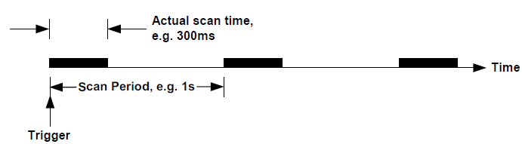

**Figure 2.1: Scan Period Command**

Defining the scan period gives two advantages: (a) it provides a manageable amount of useful data for the PC, and (b) the data becomes available at predictable intervals, thus simplifying the reading of the data.

On power-up, the scan period is set to the default value of 0ms, which allows the IMP to output scan data at the fastest rate possible. With this, however, the intervals at which data becomes available are unpredictable and, if the PC is unable to cope with the large amount of data produced, the system may hang. To make scanned data more manageable and predictable, the scan period defined by the SP command should also allow the PC enough time to process each block of scan data as it occurs. For a guide, the average scan times for the various types of IMP and their measurement modes are listed in Table 2.10.

The scan period may be re-defined at any time. If a defined scan period is in operation, the new period effectively merges with the old one. (See **note** on exception to this.) For example, consider a scan with a defined period of 5 seconds that has been running for one second. Commanding a new scan period of four seconds causes the next scan to start in three seconds.

Conversely, if the new scan period is one second or less, the next scan starts immediately on completion of the present scan. Note that a scan is never terminated by re-definition of the scan period.

**Note:** When a new scan period is loaded with the LO command (with continuous scanning),

the new period takes effect from the beginning of the next scan.

An IMP can not be made to output data faster than the inherent measurement rate. If the defined scan period is less than the actual scan time, the IMP outputs the scan data at the maximum uncontrolled rate.

The defined scan period is not effective for single scans. With the continuous mode

inoperative, scans start immediately on trigger. To ensure long term repeatability of the defined scan period, the analogue type IMP has its’ internal calendar clock synchronised to the time in the 4C Interface card. Synchronisation occurs every second. (Due to the uncertainty of the clock in the PC/4C Interface card, a small number of scans may be lost or gained over a 24-hour period. This number is ≤ 2500÷*scan period*, where the scan period is in milliseconds.)

##### **Table 2.10: Average scan times for Fast Integration IMP devices**

|  |  |  |  |  |  |
| --- | --- | --- | --- | --- | --- |
| **IMP type** | **Measurement mode** | **Average * Scan Time (ms)** | | | |
| **FR2** | **FR3** | **FR4** | **FR5** |
| 3595 1A | Voltage | 189 | 159 | 81 | 71 |
| 3595 1B | Voltage | 176 | 155 | 95 | 84 |
| 3595 1C/1E | Voltage | 225 | 196 | 112 | 111 |
| 3595 1A | Thermocouple | 300 | 292 | 270 | 269 |
| 3595 1C/1E | Thermocouple | 337 | 328 | 311 | 309 |
| 3595 1A | Thermocouple with OCTD | 403 | 385 | 338 | 335 |
| 3595 1C/1E | Thermocouple with OCTD | 474 | 454 | 408 | 408 |
| 3595 1B | Strain | 360 | 328 | 238 | 221 |
| 3595 1B | Resistance | 284 | 254 | 168 | 151 |
| 3595 1B | Temperature (PRT) | 355 | 322 | 234 | 121 |

**Notes on Autoscan Firmware**

1. IMP types not fitted with Autoscan firmware will ignore the SP command.
2. IMP types that have the Autoscan firmware are:

3595 1A/3595 51A Mod. Strikes C13/A9

3595 1B/3595 51B Mod. Strikes C17/10

3595 1C/3595 51C Mod. Strikes C16/A9

3595 2A/3595 52A Mod. Strikes B12/A10

3595 1E/3595 51E Mod. Strikes A1

3595 2B/3595 52B Mod. Strikes A1

3595 1H Mod. Strikes A1

3595 1J Mod. Strikes A1

1. IMP devices that may be fitted retrospectively with the Autoscan firmware are:

35952A Mod. Strike B11, Issue X

359552A Mod. Strike A9. Issue X

1. All IMP interfaces must be fitted with the correct issue of firmware – that is, firmware to issue AE. The type 4B and types 9A/9B/9D will always have the correct issue of firmware fitted.

**Example:** An example of a command string, in IMPVIEW, using the SP command is:

AR;SP’100’;CO;TR

**Where:**  AR arms the IMP,

SP’100’ sets a scan period of 100ms,

CO enables the continuous mod, and

TR triggers the IMP

This command string instructs the IMP to scan all channels of the IMP, continuously every 100ms.

##### **SCAN SYNCHRONISATION OF THE 1H AND 1J IMP TYPES**

To make it possible for scans to be synchronised, the 1H and 1J IMP types are able to delay the start of a scan from the trigger. This is so that, in each IMP, the scan begins at a pre-defined subdivision boundary of a second, minute or hour. Each IMP clock is synchronised to that of the PC. Therefore, all scans will start at the same point in time. The time subdivision used for scan synchronisation equals the scan period, where this is an integral sub-multiple of 100ms (1s), 60000ms (1m) or 3600000 (1h).

The algorithm that each 1H and 1J IMP uses for scan synchronisation operates as shown in Figure 2.2.

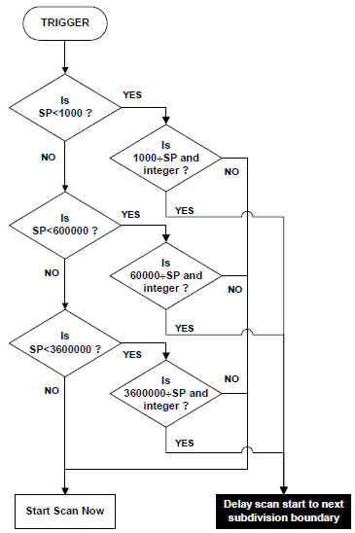

**Figure 2.2: Scan synchronisation of 1H and 1J IMP types**

**Example:**  The command SP ‘250’ is given, which specifies a scan every 250m.

1000÷250 = 4 (remainder 0). Therefore, depending on the time at which the trigger occurs, the scan is

delayed until 0ms, 250ms, 500ms or 750ms past the second:

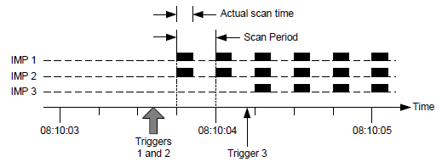

**Figure 2.3: SP ‘250’ Command Example**

A scan starts within 50ms (worst case) of the required time.

Only the first scan is aligned. Thereafter, scans are started at the beginning of each scan period – unless the system runs out of output buffers, in which case scan alignment will be lost.

#### ST (STatus)

**ST**

**Function:** Instructs the IMP to respond with information on type of IMP, connector block, and

firmware fitted.

**Response:** Stream 3, 12 characters:

**x**

**z**

**y**

**n**

**n**

**f**

**r**

**c**

**b**

**x**

**Where**:

***xx***IMP code; indicates IMP type (See Table 2.11)

***b***Connector block code; indicates connector block type. (See Table 2.12)

***c***Bit function depends on the type of IMP. For the 35951D Analogue Output IMP, *c* indicates the minimum output current, ‘0’ for 0A or ‘4’ for 4mA. For all other IMP types, *c* is set to ‘A’ if the IMP is capable of responding to a **SP** command.

***r***binary counter of the number of communication retries.

***f*** If *f* = F, the IMP is capable of responding to an **FR**0 or **FR**1 command.

***nnyz***The software number, status and issue. The software numbers are related to the IMP type and are listed in Table 2.11.

**Example:** A response of 1CDA—F-03FB indicates a ‘3595 1G reed relay thermocouple’ IMP with a ‘3595 3D attenuator’ connector block and firmware version 03FB. The IMP can respond both to the **SP** command and to the **FR** command.

##### **Table 2.11: IMP Codes**

|  |  |  |  |
| --- | --- | --- | --- |
| **IMP Code**  **(xx)** | **Software No.**  **(mm)** | **IMP Type** | **Software IMP**  **Part Number** |
| 1A | 01 | Solid State (thermocouple) | 3595 1A |
| 1B | 02 | Strain Gauge | 3595 1B |
| 1C | 03 | Reed Relay (thermocouple) | 3595 1C |
| 1D | 11 | Analogue Output | 3595 1D |
| 1E | 25 | 500V Reed Relay (thermocouple) | 3595 1E |
| 1H | 30 | Universal IMP (200V ch-ch isol.) | 3595 1H |
| 2J | 30 | Universal IMP (500V ch-ch isol.) | 3595 1J |
| 2A | 04 | Digital | 3595 2A |
| 2B | 18 | Switch | 3595 2B |

##### **Table 2.12: Connector block codes**

|  |  |  |  |
| --- | --- | --- | --- |
| **Connect Block**  **Code (b)** | **Connector Block Type** | **Connector Block P/N** | |
| **Standard Block** | **Glanded Block** |
| A | Thermocouple | 3595 3A | 3596 3A |
| B | Strain Gauge | 3595 3B | 3596 3B |
| C | Digital | 3595 3C | 3596 3C |
| D | Reed Relay Attenuator | 3595 3D | - |
| E | Analogue Output | 3595 3E | - |
| F | Switch | 3595 3F | - |
| J | Universal | 3595 3J | - |
| W | Universal Calibration | 3595 3W | - |
| Y | Analogue Output Calibration | 3595 3Y | - |
| Z | Calibration | 3595 3Z | - |
| ? | Unknown | - | - |

#### TR (TRigger scan)

**TR**

**Notes:** This command does not apply to type 1D IMP devices.

If trigger ‘broadcasting’ is to be used, please read the relevant sub-section in Chapter A of the 3595 4A, 3595 4B, or 3595 9A/9B/9D Operating Manual, before implementation.

**Function:** Instructs an ARmed IMP to make a measurement scan. An IMP must already be ARmed to respond. If CO has already been transmitted, continuous scanning will be started by the TR command.

On IMP types other than the 1H and 1J, the channels set for event capture, skip, or digital output, are not affected by this command, but return ‘not measured’ instead. However, the digital channels (19 and 20) on the 1H and 1J IMP types, when set for digital output, respond to an ME command by returning the present status.

TRigger will start counting on all channels set to ‘event count increment’ or ‘event count totalise’, provided counting has not already started. If counting has already started, Trigger will return to number of events recorded so far; additionally, channels set to ‘event count increment’ will begin counting from zero.

**Response:** Stream 0. Each IMP transmits a 4-byte result for each of its’ channels. If the status-data-format command instructs the Switch type IMP for compressed data, this data will appear over stream 3 as a 9-byte quantity.

**See also:** AR, EV, SF and (for 1H and 1J IMP types) RM.

### COMMANDS FOR ANALOGUE MEASUREMENTS ONLY

#### CA (CAlibrate)

*r*

**CA**

**Where**: *r* is an integer (1 ≤ *r* ≤ 8) which defines the analogue input range to be calibrated.

**Note:** This command does not apply to 1D, 2A or 2B IMP types.

**Function:** Allows calibration of a specified measurement range on an IMP. Calibration should normally be left to Measuresoft or to those users with specialist reference equipment.

**Equipment and Procedure:** These are detailed in the operating manual entitled ‘Calibration of the 3595 Series Analog IMPs’ (P/N: 35952233).

#### SR (DRift correct)

*d*

**DR**

**Where:** *d* = 0, continuous update (default setting)

*d* = 1, fixes drift correct value to existing setting

*d* = 2, sets drift correct value to a nominal test value

**Note:** This command does not apply to 1D, 2A or 2B IMP types.

**Function:** This command is intended for diagnostic and test purposes only. An analogue IMP continuously corrects for drift in between measurements. By using the **DR** command, the correction may be continuously updated, frozen at the last value or set to a specific test value.

**Response:** None.

#### FR (Set integration time)

*f*

**FR**

**Where**: f = 0 20.00ms integration time for 50Hz (or 400Hz supply areas).

f = 1 16.67ms integration time for 60Hz supply areas.

f = 2 5.00ms integration time for 400Hz supply areas.

f = 3 4.17ms integration time.

f = 4 1.25ms integration time.

f = 5 1.04ms integration time.

**Note:** This command does not apply to 1D, 2A or 2B IMP types. Furthermore, IMP types 1A and 1C must have software status ‘E’ onwards and IMP type 1B must have software status ‘C’ onwards to be able to comply with the commands FR2, FR3, FR4 and FR5.

**Function:** Sets the integration time of all analogue measurements. It provides for optimum rejection of 50Hz, 60Hz or 400Hz supply frequencies. Also allows a shorter integration time to be selected for increased scan rates, at the expense of reduced interference rejection. (Note: A ‘scan’ refers to the series of measurements made on all IMP channels and obtained on data stream 0.) Typical scan rates (scans per second) obtained with shorter integration times are show in Table 2.13.

The scan rates shown in Table 2.13 are for individual IMP devices on a fixed voltage range. (See SP command for further information.) Mixing fast and slow IMP devices in a large system may result in the fast IMP being slowed down.

xxxxxx shows the effect on the overall scan rate of increasing the number of fast IMP devices (types 1A and 1B) in a five-IMP system. With a small system, such as this, the fast IMP devices are not slowed down by the slow IMP devices. Actual throughputs are also dependent on the PC and the application software.

**Response:** Error FF87 ‘Unknown mode, type or range’ is returned instead of a measurement value when an unsupported integration time is requested.

**See also:** SP

##### **Table 2.13: Scan rates V integration times for totally fast IMP system**

|  |  |  |  |
| --- | --- | --- | --- |
| **Integration Time** | **Scans per second** | | |
| **3595 1A** | **3595 1B** | **3595 1C** |
| 20ms (FR0) | 1.56 | 2.01 | 1.48 |
| 16.67ms (FR1) | 1.88 | 2.38 | 1.78 |
| 5.00ms (FR2) | 5.41 | 5.85 | 4.48 |
| 4.17ms(FR3) | 6.45 | 6.63 | 5.16 |
| 1.25ms(FR4) | 12.95 | 11.33 | 9.10 |
| 1.04ms(FR5) | 14.83 | 12.50 | 9.38 |

##### **Table 2.14: Scan rate (scan/sec) v no. of fast five-IMP system**

|  |  |  |  |  |  |
| --- | --- | --- | --- | --- | --- |
| **No. of Fast**  **IMPs (FR2)** | **No. of Fast**  **IMPs (FR4)** | **Combined Scan**  **Rate of Fast IMPs** | **No. of Slow**  **IMPs (FR0)** | **Combined Scan**  **Rate of Slow IMPs** | **Overall Scan**  **Rate** |
| 1 | - | 5 | 4 | 4 | 5 + 4 = 9 |
| 2 | - | 10 | 3 | 3 | 10 + 3 = 13 |
| 3 | - | 15 | 2 | 2 | 15 + 2 = 17 |
| 4 | - | 20 | 1 | 1 | 20 + 1 = 21 |
| 5 | - | 25 | 0 | 0 | 25 + 0 = 25 |
| - | 1 | 10 | 4 | 4 | 10 + 4 = 14 |
| - | 2 | 20 | 3 | 3 | 20 + 3 = 23 |
| - | 3 | 30 | 2 | 2 | 30 + 2 = 32 |
| - | 4 | 40 | 1 | 1 | 40 + 1 = 41 |
| - | 5 | 50 | 0 | 0 | 50 + 0 = 50 |

#### KA (calibration off)

*n*

**KA**

**Note:** This command does not apply to the digital IMP (types 2A and 2B).

**Function:** With calibration ‘on’, measurements are corrected with the offset and scale factors kept in EEPROM. These factors are determined during factory calibration, or changed by the calibrate command (CA, CH CV or CH CI), and suit the individual IMP. This function defaults to ‘on’.

With calibration ‘off’, the correction factors used assume perfect components. This provides the user with a reference or a means to operate with a missing, corrupted, or non-programmed non-volatile memory.

**Response:** None.

**See also:** CA, CH CV and CH CI

#### UN (UNits of temperature)

*n*

**UN**

**Note:** This command does not apply to IMP types 1D, 2A and 2B.

**Function:** Decides the units of temperature used for:

1. Temperature measurement results (thermocouple and RTD).
2. Setting the external reference temperature with the TR command.

The IMP default is °C (on power-up).

**Response:** None.

### COMMANDS FOR THERMOCOUPLE MEASUREMENTS

#### AM (AMbient temperature reference)

**AM**

**Note:** This command applies only to IMP types 1A, 1C, 1E, 1H and 1J.

**Function:** Instructs the IMP to use the ambient temperature as a reference for those channels set for thermocouple measurement. The ambient temperature is sensed by a thermistor in the IMP connector block. This is the default (power-up) condition.

To set an external temperature reference, use the **TE** command.

**Response:** None.

**See also:** TE

#### TE (set external temperature reference)

*b*

**TE**

**Where:** *t* is the external reference junction temperature, defined by an IEEE 754 floating-point number in the range:

-30°C/-22°F ≤ t ≤ 80°C/177°F

**Note:** This command applies only to IMP types 1A, 1C, 1E, 1H and 1J.

**Function:** Sets the value of the external temperature reference into the IMP. For use only when an external reference1 junction is to be used. The units used for temperature results and references are set by the UN command.

**Response:** None.

**See also**: AM and UN

1 Historically, called the ‘cold’ junction. Now known more accurately as the *reference* junction. Similarly, the ‘hot’ junction is now known as the *measurement* junction.

#### TC (set Thermocouple Checking for open circuit)

*n*

**TC**

**Where:** *n* = 0, thermocouple checking off

*n* = 1, thermocouple checking on

**Note:** This command applies only to IMP types 1A, 1C, 1E, 1H and 1J.

**Function:** With checking enabled, a second measurement follows the thermocouple measurement; thi is to confirm thermocouple integrity. Note that this may slow down the data acquisition rate to less than 1 per second. When an open circuit is detected, the measurement result is replaced with the error code. (See Chapter 2.)

**Response:** None.

### COMMANDS FOR STRAIN GAUGE MEASUREMENTS

#### CH GA (set CHannel GAuge factor)

**CH**

*g*

**GA**

*n*

**Where:** *n* is an integer that defines the channel number, in the range 1 ≤ *n* ≤ 10

*g* is an IEEE 754 floating-point number defining the strain gauge factor

**Note:** This command applies only to IMP type 1B with strain gauge(s).

**Function:** Loads the IMP database with the gauge factor required for a specified channel. A strain gauge channel can’t perform measurements until it has been **IN**itialised and the gauge factor sent to the IMP.

**Response:** None.

**See also: IN**, **CH OF**, **LO** and **SA**

#### CH OF (set CHannel OFfset and initial voltage)

*p*

*o*

**OF**

*n*

**CH**

**Where:** n is an integer that defines the channel number, in the range 1 ≤ *n* ≤ 10

o is an IEEE 754 floating-point number defining the offset in volts

p is an IEEE 754 floating-point number defining the initial gauge voltage

**Note:** This command applies only to IMP type 1B with strain gauge(s).

**Function:** Sets the strain gauge offset and initial voltage values used by an IMP to calculate strain results. These values will have been returned by the **IN**itialise command and should be stored in the PC. After an IMP has been powered-down, this command can be used to set up a strain gauge channel to the original condition set by the previous **IN** command.

This must be used in conjunction with the **CH GA** command before the strain gauge can return data.

**Response:** None.

#### IN (INitialise strain gauge parameters)

*n*

**IN**

**Where:**  *n* is an integer that defines the channel number, in the range 1 ≤ *n* ≤ 10

**Note:** This command applies only to IMP type 1B with strain gauge(s).

**Function:** Before a strain gauge channel can be used, the IMP must first know the initial voltage of a gauge connected to a specified channel, to store this, and also transmit this data to the PC. The IMP must then be informed of the gauge factor using the CH GA command. The IMP uses these parameters to calculate strain results and unless the IMP holds these parameters, it will return the error ‘strain gauge not initialised’ when commanded to measure.

The PC should be programmed to store the strain gauge data as a string and later (if

necessary) send it back to the IMP using the **LO** or **CH OF** commands. This allows a re-start after the IMP has been powered down.

**Response:** Stream 1, 8 bytes

r

r

r

r

o

o

o

o

*oooo* = out-of-balance voltage, represented by 4 bytes.

*r r r r* = initial gauge voltage, represented by 4 bytes.

**See also: CH GA**, **CH OF**, **SA** and **LO**

### ****COMMANDS FOR DIGITAL MEASUREMENTS ONLY****

#### CH RA (set CHannel sample RAte)

**CH**

*d*

**RA**

*n*

**Where**: *n* is an integer that defines the channel number, in the range 1 ≤ *n* ≤ 20

*d* is an integer that defines the sample rate, in the range 1 ≤ *d* ≤ 4

**Note:** This command applies only to IMP types 1H, 1J and 2A. In the case of the 1H and 1J IMP types, the command applies only to channels 19 and 20.

**Function:** Sets the sample rate for the specified channel. The sample rates selectable are listed in Table 2.15. On power-up, the IMP selects the default sample rate. This rate is suited to mode of operation, as shown in Table 2.16.

At the sample rates of 20Hz and 1kHz, a level change is detected only if four consecutive samples are the sample value. This improves immunity against contact bounce and similar effects. Note, however, that the time recorded for event capture is four sample periods ‘late’ at the lower sample rates.

**Response:** None.

##### **Table 2.15: Sample rate settings**

|  |  |
| --- | --- |
| **Rate setting (d)** | **Sample rate selected** |
| 0 | Default (as on power up) |
| 1 | 20Hz |
| 2 | 1kHz |
| 3 | 10kHz |
| 4 | 100kHz |

##### **Table 2.16: Default sample rates**

|  |  |
| --- | --- |
| **Mode** | **Default Sample Rate** |
| Digital status | 20Hz |
| Event counting | 1Hz |
| Event capture | 1kHz |
| Frequency | 100kHz |
| Period | 100kHz |
| One-shot time | 100kHz |

#### CH TI (set CHannel TIme-out)

**CH**

*p*

**TI**

*n*

**Where**: *n* is an integer that defines the channel number, in the range 1 ≤ *n* ≤ 20

*p* is an integer that defines the time-out code, in the range 0 ≤ *p* ≤ 5

**Note:** This command applies only to IMP types 1H, 1J and 2A.

**Function:** For a specific channel, sets the time-out period for period measurements. The settings available are listed in Table 2.17. The default period is 2 seconds (p = 1)

The time-out period is the maximum time any period or ‘one-shot’ measurement is allowed to take. If the period to be measured exceeds this time, the error ‘period time-out’ is returned instead of a result. For single period measurement of cyclic signals, the time-out period must be at least twice that of the measured signal. This ensures both edges of the signal are within the time-out period.

**Response:** None

##### **Table 2.17: Time-out periods**

|  |  |
| --- | --- |
| **Time-out code** | **Time-out Period** |
| 0 | 200ms |
| 1 | 2s |
| 2 | 20s |
| 3 | 50s |
| 4 | 70s* |
| 5 | 130s* |
| * Available on 1H and 1J IMP types only | |

#### CL (CLear event totalise counter)

*n*

**CL**

**Where:** *n* is an integer that defines the channel number, in the range 1 ≤ *n* ≤ 20

**Note:** This command applies only to the digital IMP (type 2A) and the Universal IMP (types 1H and 1J).

**Function:** Instructs the IMP to clear its’ event totalise counter and to inhibit counting until the next **ME** or **TR** command, for a specified channel only. The event totalise counter keeps a continuously updated record of the number of events that have occurred since an initial **ME** or **TR** command. It can only be cleared by a power-down or the **CL** command. Maximum count value = 16,777,215.

**Response:** None.

#### EV (enable EVent capture)

*e*

**EV**

**Where:** e = 0, stop event capture

e = 1, enable event capture

**Note:** This command applies only to the digital IMP (types 2A and 2B).

**Function:** Enables event capture on any channels in the IMP already set to ‘event capture mode’. Event capture can be enabled or stopped only by this command.

**TR**igger, **AR**m or **ME**easure commands have no effect on event capture.

**Response**: Event data is sent to stream 2. For a detailed explanation on event result formats, see Chapter 2.

**See also: CH MO** and **ES**

#### ES (Event Status)

**ES**

**Note:** This command applies only to digital IMP (types 2A and 2B)

**Function:** This command checks the configuration for channels selected for event capture, and for each one, inserts an event status result with time tag into the event buffer. This command operates independently, whether events are enabled or not. If the event buffer is full, this command, in part or in full, is ignored. It will not affect the events lost count.

Note: Only a digital IMP with a product status marked B4 onwards and the Switch IMP are able to comply with this command.

**Response:** Event Status data is sent in stream 2. For a detailed explanation on event status formats, see Chapter 2.

**See also: CH MO** and **EV**

#### HW (Hardware Watchdog)

*n*

**HW**

**Where:** *n* = 0, to disable the watchdog

*n* = 1, to enable the watchdog

**Note:** This command applies only to the Universal IMP (types 1H and 1J), and digital IMP type 2B.

**Function:** Enables or disables the hardware watchdog. Once the watchdog is enabled, the watchdog output channel (channel 20 for UIMP or 32 for digital IMP) goes from a ‘0’ state to a ‘1’ (no alarm) state. If a time-out period passes without the IMP being ‘patted’, the output is set to a ‘0’ (alarm) state. The IMP is reset into the power-up state. The watchdog can then be re-enabled by sending the **HW1** command. Disabling causes the output to go into the ‘0’ state. Once the watchdog is enabled, power-down forces the output into the ‘0’ (alarm) state. The **RE** command does not disable the watchdog.

**Response:** None.

#### SF (Status data Format)

*n*

**SF**

**Where**: *n* = 0, for IEEE 754 floating-point format

*n* = 1, for binary compressed format

**Note:** This command applies only to the Switch IMP type 2B.

**Functions:** Command **SF** defines whether scan data is supplied as IEEE 754 floating-point numbers (128 bytes) in stream 0 or as a binary compressed quantity (9 bytes) in stream 3, for the single trigger or continuous mode of operation. The default value is for IEEE 754 floating-point format.

The binary format consists of:

Byte 1 ASCII character ‘%’ (37 decimal)

Bytes 2-5 Binary inputs from channels 1 to 32, starting from bit 7 of byte 2 to bit 0 of byte 5 for channels.

Bytes 6-9 Control bytes (one bit per channel). A bit value of ‘0’ indicates that the channel is set to status input. A bit value of ‘1’ indicates the channel is ‘Not measured’ or ‘Unknown mode, type or range’.

**Response:** None.

#### SW (Software Watchdog)

*n*

**SW**

**Where**: *n* = 0, to disable the software watchdog

*n* = 1 to 255, to set the software watchdog time-out (in seconds)

**Note:** This command applies only to the Universal IMP (types 1H and 1J), and digital IMP type 2B.

**Function:** Enables or disables the software watchdog. Once the watchdog is enabled, the watchdog output channel (channel 20 for UIMP or 32 for digital IMP) goes from a ‘0’ state to a ‘1’ (no alarm) state. The IMP then expects the ST command to be sent within every ‘n’ seconds. If a time-out period passes without a ST command being received, the output is set to a ‘0’ (alarm) state. (The IMP is not reset.) Disabling causes the output to go into the ‘0’ state. The **RE** command does not disable the watchdog.

Note: Enabling either watchdog causes the output to go into the ‘1’ (no alarm) state. For the output to be disabled from the watchdog, both the hardware and software watchdogs need to be disabled.

**Response:** None.

### ****COMMANDS FOR ANALOGUE OUTPUTS****

#### CH VO (CHannel VOltage Output)

**CH**

*x*

**VO**

*n*

**Where:** *n* is an integer that defines the channel number, in the range 1 ≤ *n* ≤ 4

*x* is the output voltage in 4-byte floating-point format, in the range -10 ≤ *x* ≤ +10

**Note:** This command applies only to IMP type 1D.

**Function:** Sets the specified channel to the specified voltage.

**Response:** None.

**See also:** OS.

#### CH IO (CHannel Current)

**CH**

*x*

**IO**

*n*

**Where**: *n* is an integer that defines the channel number, in the range 1 ≤ *n* ≤ 4

*x* is the output current (amps) in 4-byte floating-point format:

* in the range 0.000 ≤ *x* ≤ 0.02, or
* in the range 0.004 ≤ *x* ≤ 0.02, if the split pad on the converter block is made. (See the IMP Installation Guide)

**Note:** This command applies only to IMP type 1D.

**Function:** Sets the specified channel to the specified current in amps.

**Response:** None.

**See also:** OS.

#### CH CV (CHannel Calibrate Voltage)

*y*

*x*

**CV**

*n*

**CH**

**Where**: *n* is an integer that defines the channel number, in the range 1 ≤ *n* ≤ 4

*x* = the measured voltage value, corresponding to an non-calibrated 0V output

*y* = the measured voltage value, corresponding to an non-calibrated 10V output

Values *x* and *y* are both in volts, in floating-point format.

**Note:** This command applies only to an IMP type 1D with a ‘3595 3Y’ connector block.

**Function:** Allows voltage calibration of a specific output channel. This should normally be left to users with specialist reference equipment.

**Response:** Stream 3, 4 characters **C*n*V*e***, where: *n* is the channel number and *e* represents the

calibration response, as shown in Table 2.18.

**Equipment:** The calibration equipment required for IMP type 1D is:

1. An ‘analogue output’ connector block (P/N: 35953Y). This allows the IMP to recognise the calibrate commands
2. A stable temperature environment of 20°C±3°C. The IMP should be powered-up and allowed to stabilise at this temperature, ideally for 24 hours
3. An accurate multimeter to measure the output channels.

**Procedure:** The procedure for calibrating the output voltage of a type 1D IMP is:

1. Fit all cables to the ‘3595 3Y’ connector block. PCB terminal connectors are as shown in Figure 1.4.
2. The S-Net cable is connected to the ‘COMMS IN’ terminals. Strictly observer + to + and - to – polarity, and the S (screen) to S connections throughout the network.
3. The multimeter is connected to the channel to be calibrated.

Note: To avoid signal reflections, a terminator connector (P/N: 35900222) must be connected across the ‘COMMS OUT’ terminals of the last IMP in the system. (The terminator connector is supplied with the S-Net host interface package.)

1. Set the rotary address switches on the ‘3595 3Y’ connector block PCB to a number between 01 and 50.
2. Insert the ‘3595 3Y’ connector block into the IMP to be calibrated
3. Power-up the PC.
4. Turn the calibration mode off by sending the **KA1** command to the IMP.
5. Using the **CH VO** command, set the channel output voltage first to 0V and second to 10V, and in each case, measure the voltage actually output by the IMP.
6. Using the measurements obtained in Step 6, send the channel calibrate voltage command **CH*n*CV*xy***. In this command, *x* is the actual voltage measured when 0V was requested and *y* is the actual voltage measured when 10V was requested.
7. Check the calibration response in stream 3 (see Table 2.18) to ensure that the IMP channel has been successfully calibrated.

##### **Table 2.18: Calibration responses**

|  |  |
| --- | --- |
| **e Code** | **Meaning** |
| 0 | Calibration completed |
| 1 | Invalid range* |
| 2 | EEPROM fault: missing or not working |
| 3 | ‘35953Y’ calibration connector not fitted |
| * e = 1 is caused either by an arithmetic error in calculating the calibration coefficients or by the same coefficients not allowing the full range of the channel to be utilised. Either an incorrect measurement was made or there is a faulty circuit in the IMP | |

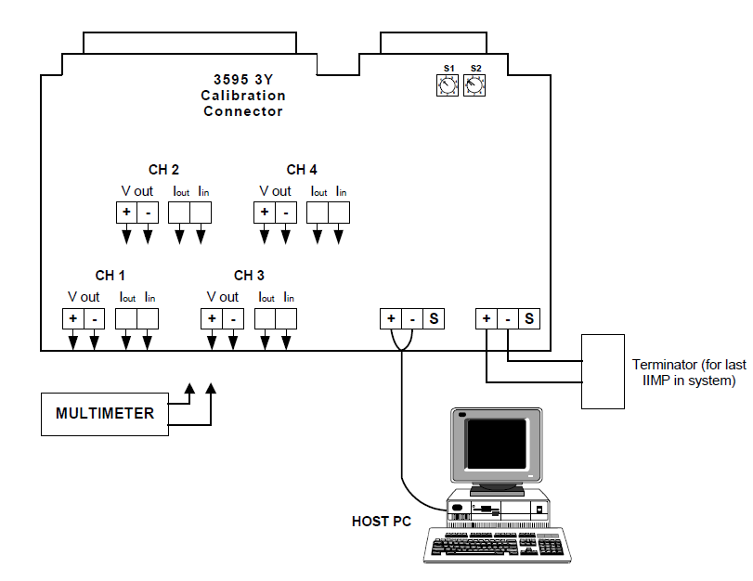

**Figure 2.4: connections to ‘3595 3Y’ calibration block connector**

#### CH CI (CHannel Calibrate current)

*y*

*x*

**CI**

*n*

**CH**

**Where**: *n* is an integer that defines the channel number, in the range 1 ≤ *n* ≤ 4

*x* = the measured current value, corresponding to an non-calibrated 0.004A output

*y* = the measured current value, corresponding to an non-calibrated 0.02A output

Values *x* and *y* are both in amps, in floating-point format.

**Note:** This command applies only to an IMP type 1D with a ‘3595 3Y’ connector block.

**Function:** Allows current calibration of a specific output channel. This should normally be left to users with specialist reference equipment.

**Response:** Stream 3, 4 characters **C*n*I*e***, where: *n* is the channel number and *e* represents the calibration response, as shown in Table 2.18.

**Equipment:** Same as for **CH CV** command.

**Procedure:** The procedure for calibrating the output current of a type 1D IMP is:

**1 – 5** Same as for **CH CV** command.

**6.** Using the **CH VO** command, set the channel output current first to 0.004A and second to 0.02A, and in each case, measure the current actually output by the IMP.

**7.** Using the measurements obtained in Step 6, send the channel calibrate current command **CH*n*CI*xy***. In this command, *x* is the actual current measured when 0.004A was requested and *y* is the actual voltage measured when 0.02A was requested.

**8.** Check the calibration response in stream 3 (see Table 2.18) to ensure that the IMP channel has been successfully calibrated.

#### OS (Output Status)

**OS**

**Note:** This command applies only to IMP type 1D.

**Function:** This command returns the status of the analogue channels.

**Response:** Stream 3, 12 characters:

**3**

**e**

**d4**

**e**

**d1**

**d3**

**e**

**d2**

**e**

**0**

Where:

digits ***d1 d2 d3 d4*** relate to channels 1, 2, 3 and 4; they are either ‘V’ or ‘I’, depending on whether the last command sent to that channel was **CH***n***VO***x* or **CH***n***CI***x*.

e represents the output status code as shown in Table 2.19.

For example, ’30 V0V0I0I0’ shows that channels 1 and 2 have been correctly set for ‘voltage output’ and channels 3 and 4 have been correctly set for ‘current output’

##### **Table 2.19: Analogue Output Status codes**

|  |  |
| --- | --- |
| **e Code** | **Meaning** |
| 0 | OK (channel is correctly set) |
| 1 | Calibration mode ‘on’ but calibration data corrupt. (* and **) |
| 2 | Value requested is out of range (**) |
| * EEPROM not fitted or IMP not yet calibrated | |
| ** The last channel output command sent to that channel was not executed | |

### ****ADDITIONAL COMMANDS FOR 3595 IMP TYPES 1H AND 1J****

#### DEFINITION OF TERMS:

**Physical Channel**

These are the twenty channels present on the IMP connector block, in the range of one through twenty.

**User Unit Conversion**

A simple first-order conversion of the measurement unit (resulting from CHannel MOde) to required unit.

**User Linearisation**

A fifth-order linearisation from the measurement unit (resulting from CHannel MOde) to required unit.

**Real-time Mode**

An IMP outputs data in this ‘standard’ mode. The messages are streamed and real-time results appear without a timestamp in Stream 0. For IMP types 1A, 1B, 1C, 1D, 1E, 2A and 2B, this is the only mode available. The same mode can also be selected for IMP types 1H and 1J, but there are two additional modes available: *time tag* mode and *historical* mode. (See below)

**Time Tag Mode**

Same as real-time mode with an extended Stream 0 that includes a time tag.

**Historical Mode**

This mode is unique to IMP types 1H and 1J and does not use Streams 0 and 1. Stream 2 is enlarged to fill the first 240 bytes of the receive page. All results, alarms, etc. from the IMP are passed through with a timestamp. This mode must be used if buffering of IMP data during S-Net downtime is required. Stream 3 is preserved to return status and error information. (*Do not use the SA command while in continuous* *historical mode, since this command uses Stream 0 and overlaps the same data space on the 3595 4C* *Interface card*.)

**Logic States**

When channels 19 and 20 are used for ‘digital status’ inputs, the logic states recognised are:

* logic 1 = switch open (off) = high impedance
* logic 0 = switch closed (on) = low (zero) impedance

When the IMP is powered off, the switch is high impedance and is read as a ‘1’ by another IMP. The digital channel output maintains this state until changed by a set-up command.

#### CH LR (CHannel Loop Resistance)

**LR**

*n*

**CH**

**Where:** *n* is an integer that defines the channel number, in the range 1 ≤ *n* ≤ 18

**Function:** Reports the loop resistance, between *high* and *low*, of a thermocouple on channel n.

Channel *n* must be configured as a thermocouple type (**MO**de 310 – 3A4). If *n* is out of range, the command does not return an error and is ignored.

**Response:** In Stream 3:

**CH***n***LR** <4-byte result>

The result is in kohms – no time lag.

#### CH UC (CHannel Unit Conversion)

*c*

*e*

*n*

*m*

**UC**

**CH**

**Where**: *n* is an integer that defines the channel number, in the range 1 ≤ *n* ≤ 18

*m* is an IEEE 754 floating-point number defining the slop of a line,

*c* is an IEEE 754 floating-point number defining a constant (y-axis catersian intersection)

*e* is an enable flag (1 = enable, 0 = disable)

**Function:** Used to convert a measured parameter into alternative units with the function:

*y = mx + c*

Where *x* is the *input* parameter and *y* is the *output*.

**Notes:**

1. The *input parameter* is post Channel Mode. Therefore, if the required *output* is pressure and the *input* is measured from a 4-20mA transmitter, two conversions are possible:
2. From a measured voltage across a precision resistor, through which the current flows (unit conversion is post CHannel MOde voltage).
3. From a measured current, through a 100Ω precision resistor (unit conversion is post CHannel MOde current).
4. Once the measured parameter has been converted, it is no longer available (as current or voltage for example)

#### UT (User Thermocouple linearisation)

**b5 –b0**

**a5 – a0**

**I**

**UT**

**Where**: < *I* > defines the user thermocouple as Thermocouple ‘1’ or ‘2’

*a5 – a0* are IEEE 754 floating-point numbers for the coefficients of a fifth-order polynomial

*b5 – b0* are IEEE 754 floating-point numbers for the coefficients of a fifth-order polynomial, butare the inverse of the *a5 – a0* polynomial.

**Function:** This command is used to apply a user-defined linearisation to a thermocouple measurement. The aim is to cover any thermocouple type not covered by the polynomials available in 3595 IMP types 1H and 1J). (Channel modes 390 – 394 use the coefficients defined by **UT1**. Modes 3A0 – 3A4 use coefficients defined by **UT2**.)

The computation of reference junction 2 compensation requires both the linearisation

polynomial and its’ inverse. User-defined thermocouple linearisation acts in the same way as predefined thermocouple linearisation with respect to the **AM**, **TR** and **TC** commands. (See mode codes 310 – 3A4 in Table 1.7, page 1-14)

**Notes:** If a thermocouple is measured and the corresponding linearisation equation has not been defined, the error code FF82*xxxx* is returned instead of the 4-byte result.

**See also: CH MO**

#### CH PL (Post Linearisation)

**I**

**PL**

*n*

**CH**

**Where**: *n* is an integer that defines the channel number, in the range 1 ≤ *n* ≤ 18

< *I* > defines the user-defined linearisation equation to use, ‘1’ or ‘2’ (‘0’ disables post

linearisation on channel n)

**Function:** Enables conversion of a measured parameter into alternative units, with the linearisation function:

*y* = *a*5 *x5* + *a4 x4* + *a3 x3* + *a2 x2* + *a5 x5* + *a0*

Where *x* is the *input* parameter and *y* is the *output*. The coefficients used are those defined by the **PL** command.

**Note:** The **CH PL** command can be used with channel unit conversion. Post linearisation is applied first and then the unit conversion.

**See also: PL**

2 Historically, called the ‘cold’ junction. Now known more accurately as the *reference* junction. Similarly, the ‘hot’ junction is now

known as the *measurement* junction.

#### PL (Post Linearisation)

**a5 – a0**

**PL**

**I**

**Where**: < *I* > defines the linearisation equation to use, ‘1’ or ‘2’

*a5 – a0* are IEEE 754 floating-point numbers for the coefficients of a fifth-order polynomial

**Function:** Defines the coefficients of the polynomial that is applied by a **CH PL** command. If the polynomial is undefined, the result returned is zero and not an error code

**See also: CH PL**

#### CH HL (CHannel High Limit)

**CH**

*n*

**HL**

**limit**

*i*

**Where:** *n* is an integer that defines the channel number, in the range 1 ≤ *n* ≤ 18

<*limit*> is an IEEE 754 floating-point number that defines the limit in channel units

< *i* > is an IEEE 754 floating-point number that defines the limits for hysteresis (in units)

**Function:** Defines the high limit for alarm checking on a channel. This is used only in conjunction with the **CH GO** command.

The effect of hysteresis is described in the following example:

1. The limit for a thermocouple is set to 100°C.
2. Hysteresis is set to 3
3. With a rising temperature, an alarm is signalled at 113°C. The signal remains until the temperature falls below 107°C.

**See also: CH LL** and **CH GO**

#### CH LL (CHannel Low Limit)

**CH**

*n*

**LL**

**limit**

*i*

**Where**: *n* is an integer that defines the channel number, in the range 1 ≤ *n* ≤ 18

<*limit*> is an IEEE 754 floating-point number that defines the limit (in channel units)

< *i* > is an IEEE 754 floating-point number that defines the limits for hysteresis (in units)

**Function:** Defines the low limit for alarm checking on a channel. This is used only in conjunction with the **CH GO** command.

The effect of hysteresis is described in the following example:

* + - 1. The limit for a thermocouple is set to 10°C.
      2. Hysteresis is set to 3.
      3. With a falling temperature, an alarm is signalled at 7°C. The signal remains until the temperature rises above 13°C.

**See also: CH HL** and **CH GO**

#### CH GO (CHannel Group alarm Output)

*string*

**HL**

*n*

**CH**

**Where:** *n* is an integer that defines the digital output channel number, 19 or 20

<*string*> is a string defining on which the analogue channels an alarm check is required.

The format for <*string*> is:

*pA1A2A3…A36*

*p* defines the output state of channel *n* for alarm detected:

* *p* = 2, disable alarm checking on channel n
* *p* = 1, FET on: switch closed, i.e. as MODE 80
* *p* = 0, FET off: switch closed, i.e. as MODE 800

*An* is the identity of an alarm check and consists of an analogue channel number, in the range 1 through 18, and the character H or L. The ‘H’ specifies a high limit alarm check (See **CH HL**); ‘L’ specifies the low limit alarm check (See **CH LL**).

**Function:** Defines the group of alarms to be associated with a digital output. If any of the alarms are active (OR logic), the digital output will be active. Only the channels specified in the last **CH GO** command are checked.

The **CH GO** command provides for alarm checking on all 18 analogue channels. Checking is against the high and low limits defined by the **CH HL** and **CH LL** commands. On all analogue channels, it is possible to specify a high limit alarm check, or a low limit alarm check, or both. Specifying both alarm limit checks is equivalent to specifying an ‘out-of-window’ check. (Note that it is not possible to specify an ‘in-window’ check by specifying a high limit that is less than the low limit.)

**See also:** CH HL and CH LL.

**Notes:**

1. If *n* = 20, Watchdogs are disabled.
2. Alarm checking operates only for scanned channels, NOT for single measurements.
3. The CH GO command stays in operation, unless:
4. it is overridden by a CH MO command, or
5. another CH GO command is received, or
6. the Watchdog is enabled (channel 20 only). This command sets the MOde database to MO*80x*,where *x* = the ‘Go’ state for the channel.
7. The state of the digital output may be read at any time by measuring or scanning the channel.
8. The group may consist of one alarm element only. If *p* = 2, no alarms need be specified – alarm checking is disabled for all alarms previously specified
9. On alarm, the defined digital output is active. ‘Active’ can be defined as ‘switch closed’ or ‘switch open’, depending on the value of *p* in the command string. This gives the option of an active alarm when the IMP is non-functional.

Consider a requirement to disable a machine when off-limit readings are obtained for oil temperature, oil pressure, or both, or monitoring equipment is non-functional. The oil temperature should be in the range –10 to +95°C. The oil pressure should be in the range 1 to 3bar. The channel definitions for this scenario could be:

1. Minimum acceptable oil temperature on channel 1 (low limit): CH1LL-10.
2. Maximum acceptable oil temperature on channel 1 (high limit): CH1HL95.
3. Minimum acceptable oil pressure on channel 2 (low limit): CH2LL1.
4. Maximum acceptable oil pressure on channel 2 (high limit): CH2HL3.
5. Define channel 19 associated with the above alarm group: CH19GO001L01H02L02H.

(Note that alarms use data post-unit conversion or post-linearisation.)

While the IMP is powered-down, the digital output is open, thus disabling the machine. When the IMP first powers-up, the machine remains disabled. When CH19GO command is sent, the output is switched into the alarm state (i.e. no change in this case) thus disabling the machine. Once the IMP has read the machine parameters and determined that none are in alarm, it closes the output switch and, thus, enables the machine.

#### AS (Auto Start)

*n*

**AS**

**Where:** *n* = 0 = False – do not auto-start (default)

*n* = 1 = True – do auto-start

**Function:** When auto-start is set to *true*, the IMP automatically begins operations after a hard reset (power-up or a hardware watchdog timeout).

After a hardware reset, and just before entering an idle loop, the IMP checks the value of *n* in its’ non-volatile database. If *n* is true, the non-volatile database is restored to the database proper, as if the **RD** command had been issued. A check is then made on the CONTINUOUS_SCANNING Boolean variable: if this is true, a scan is triggered automatically; if it is false, no further action is taken.

When auto-start is set to *false*, no action is taken.

**Example:** A typical AS command sequence is:

1. **SE** (set-up the IMP to default mode)
2. **CO** (set continuous triggering)
3. **AS1** (set auto-start to true)
4. **SD** (save settings in non-volatile memory)

These commands prepare an IMP to respond to a hard reset by restoring its’ database and issuing a trigger command to itself.

#### RM (Result Mode)

*n*

**RM**

**Where:** *n* = 0 = Real-time mode (default)

*n* = 1 = Real-time mode with time-tagging. (See page 1-45)

*n* = 2 = All results returned in Stream 2 (historical)

**Function:** Mode 0 outputs data on Stream 0 in the same format as for all IMP devices. Mode 1 outputs the same data but with a time-tag. Mode 2 outputs historical data on Stream 2 and allows all 960 buffers to be used. Each buffer holds a scan of 20 channels. If, for example, the scan period is set to 10s with the SP command, the 960 buffers will be filled in 9,600 seconds (= 2hrs 40mins).

Historical mode buffering operates on a first-in, first-out basis (FIFO). If the IMP is measuring faster than the PC can read results, the results are stacked in the FIFO buffer (queue). When the buffer is full, the IMP continues measuring so that it can monitor alarm inputs, but does not store new results in the buffer until space becomes available.

#### FB (Flush Buffers)

**FB**

**Function:** Flushes the historical results (FIFO buffer) and returns the FIFO buffer to the ‘free buffer list’. **FB** is a ‘one-shot’ command and has no persistent effect. For further flushing, another **FB** command must be sent.

#### SD (Save Database) and RD (Restore Database)

**RD**

**SD**

**Function:** The SD and RD commands provide for a quick set-up.

The SD command saves the database of a previously configured IMP into a **Flash PROM**. Later, the RD command can be used to load the current contents of the Flash PROM into the same database.

When the database is restored, two things happen:

1. The watchdogs are disabled and
2. If the channel mode is 80x, the output is set accordingly.

(Refer to Appendix A for details of the database format.)

Compared with the PC saving and restoring the IMP database over S-Net, the above method is more convenient, but less flexible.

**Response:** Stream 3. Single character ‘H’ (**SD** command only). This response confirms that the

database has been written.

**Note:** Before storing the database in the Flash PROM, the **SD** command generates an internal HA (halt) command. This does not change the state of the COntinuous Scan Parameter.

While the database is being restored, there is no communication with the IMP and S-Net. This causes polling errors, which stop when storage is complete.

It can take up to three seconds for the IMP database to be restored. Therefore after sending the SD command, any software application should wait three seconds, then clear the error flags from the 3595 4C Interface card, and then read Stream 3 for an ‘H’ character. Once this is received, the IMP is ready to resume normal operations.

### SUGGESTED COMMAND PROCEDURES

Before an Imp can take a measurement, it must first be assigned a task and enabled (set-up). Only then can an IMP be instructed to take a measurement. Each result must then be read, otherwise buffer space will be filled until the IMP no longer has room to store new data and measurements will stop.

The command language used by the IMP is very versatile, allowing great flexibility in the way each channel can be configured and used. To assist in preparing a software application, suggested command procedures are outlined overleaf. The detailed function and syntax of each command is documented in the Command Directory. Once familiar with commands, procedures can be tailored to suit a particular requirement.

#### SET-UP

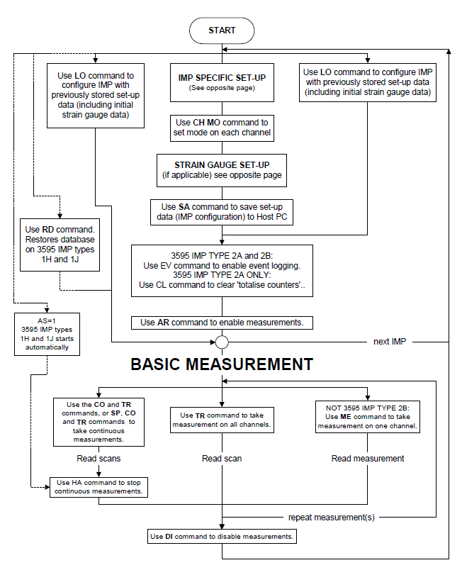

**Figure 2.5: Set-up and basic measurement**

#### IMP SPECIFIC SET-UP

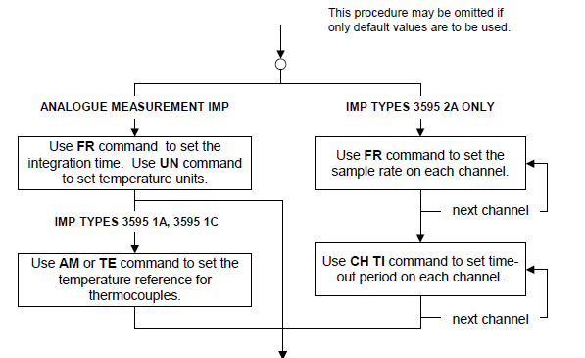

#### STRAIN GAUGE SET-UP

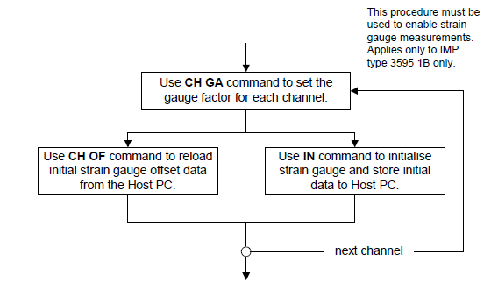

**Figure 2.6: IMP Specific and Strain Gauge Set-up**

## Chapter 2 - Result and Error Formats

### INTRODUCTION

Table 3.1 summarises the **result formats** applicable to 3595 Series IMP types 1A, 1B, 1C, 1D, 1E, 2A and 2B.

For IMP types 3595 1H and 1J, the same formats apply. However, depending on the **result mode** selected, the results may be time-tagged.

The three result modes of IMP types 3595 1H and 1J are:

* *Real-time* – exactly the same format as for all other IMP types.
* *Time*-tagged – each scan data block, or single measurement result, has a *bookmark* and *time-tag* appended.
* *Historical* – allows the IMP to pass historical time-tagged results back to the Host PC.

The formats of the bytes appended in the *time-tagged* and *historical* modes are described in Sections 3.5 and 3.6.

The error messages that may be returned by an IMP are listed in Section 3.7, together with their meanings.

**Table 3.1: IMP Result Formats**

|  |  |  |
| --- | --- | --- |
| **IMP Result** | **Stream** | **Format** |
| Scan data of all measurements, except ‘event totalise’ and ‘event increment’ | 0 | 4-byte floating-point number. |
| Scan data of ‘event totalise’ and ‘event increment’ measurements | 0 | IEEE 754 floating-point number |
| Single measurement | 1 | 4-byte floating-point number |
| Events capture  (From 3595 2A and 2B IMP types only) | 2 | Event capture results are returned in the form of bookmarks, event tags, event status, end tags and lost events. Each of these has an individual format, which is described in Section 3.4 |
| IMP status and Command responses | 3 | ASCII characters |
| Response to a SA (SAve set-up data) command | 0 | Command format (See Chapter 2, ‘IMP Commands’.) |

### IEEE 754 FLOATING-POINT NUMBER FORMAT

The IEEE 754 floating-number format is used for the ‘event totalise’ and ‘event increment’ results, as returned by the 3595 IMP types 2A and 2B. It is also used for the response to the IN command, and for the set-up parameters in several IMP commands.

To represent a number in IEEE 754 format, four bytes are used:

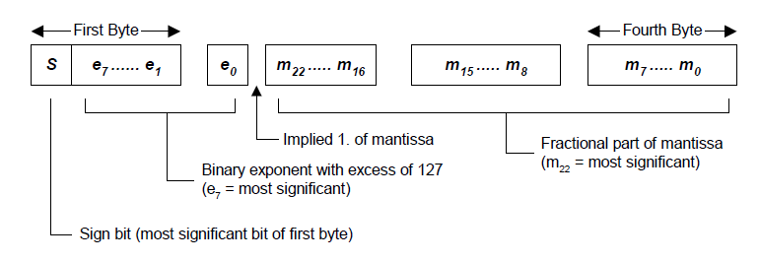

The S (sign) bit is one if the number is negative and zero if the number is positive. The binary exponent has an excess of 12710. This means that it consists of the sum of the true exponent with 12710. This allows a range of exponent values form -12710 to 12810. To retrieve the true exponent, subtract 12710. The mantissa has an ‘implied one’. Only the fractional part of the mantissa is actually written. When the number is converted to IEEE format, the exponent is adjusted until there is only a single binary one to the left of the binary zero. This binary one is then omitted and becomes ‘implied’

**Example:** To convert a decimal number of 2.25

2.2510  = 10.012  = 10.01 * 20 = 1.001 * 21

Mantissa (with implied 1) = .001

Exponent = 1

With excess of 127 = 127 + 1 = 128

This gives the result:

00000000

00000000

0010000

0

1000000

0

The result breaks down into:

Sign bit = 0, there fore the number is positive.

An exponent with the excess of 12710 = 100000002 = 12810, the true binary exponent is 110 .

Mantissa with implied 1 = 001…., a true mantissa of 1.0012

The four bytes there represent:

1.0012 * 21 = 10.012 = 2.2510

**Note:**  Zero is represented by all four bytes being ‘all zeroes’.

### FOUR-BYTE RESULT FORMAT

Analogue and digital data are sent in a 4-byte result format that closely resembles the IEEE 754 format.

The 4-byte format differs from IEEE 754 in having a shorter mantissa, that is 17 bits rather than 23. Four of the six bits are thus freed and are used to hold information on the significance of the result, as follows:

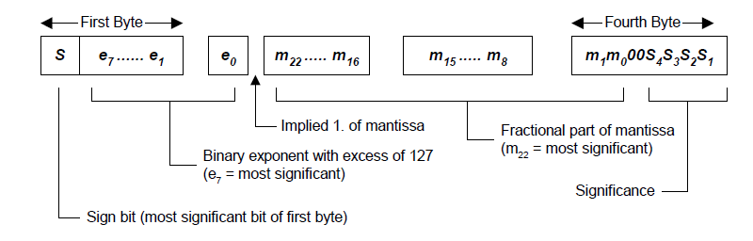

The significance is the number of valid decimal places in the result. This is decided by the range selected in the IMP.

### EVENT RESULT FORMAT

Event results are obtainable only from digital IMP type 3595 2A and switch IMP type 3595 2B, set-up for ‘events capture’. The 3595 2A IMP can store up to 6000 bytes of event data, whilst the 3595 2B can store up to 512 bytes. Both types can transmit up to 112 bytes of data at a time.

Event data carries information on the time and directional change of a digital signal. The time of a detected event is referenced to the IMP internal calendar and clock, which is regularly synchronised from the 3595 4C Interface card. Synchronisation is performed regularly and does not affect measurement integrity.

Event data is transmitted in Stream 2. If the on-card input buffer for Stream 2 and the relevant IMP is empty, the event data is transmitted as soon as it occurs. However, if the input buffer already holds unread data, the IMP stores the results and transmits the event data when the buffer is free.

Event data consists of:

*Bookmarks.* Four bytes containing the calendar month, day, hour and minute.

*Event tags.* Four bytes containing the channel number, direction of transition, calendar seconds and milliseconds. One event tag is sent per event

*End tags.* Four bytes containing only binary zeroes. This indicates the end of a set of event data, and is used when less than 112 bytes of event data is transmitted.

*Lost event results.* When the event storage area of the IMP and *on-card* input buffer are full, the

IMP has nowhere to send or store event results. Instead, it counts the number of events that occur. This data is stored in a 4-byte result and loaded into the output buffer when space is available. Up to 65535 lost events can be counted.

Event data transmitted by an IMP can consist of a number of bookmarks; event tags ad one end tag.

Only a single bookmark is sent per calendar minute (and this is only if an event occurs). A bookmark gives the most significant calendar data for all event tags sent after it, until the next bookmark is sent.

If event data is sent to a free buffer (on the 4C Interface card), data for the only one result is sent: this consists of a bookmark, an event tag and an end tag. Subsequent data is sent only if the application software reads the initial data. The IMP, whilst waiting for the buffer to become free, stores any new event tags and bookmarks. This new data is sent when the buffer is free. An end tag is added if the stream of event data is less than 112 bytes long, but this tag can be replaced by a lost event tag if one has to be sent.

Event status responses also go into Stream 2. In this case, the event tag is replaced by the ‘event status format’.

#### BOOKMARK FORMAT

A bookmark contains the calendar month, day, hour and minute, in the following format:

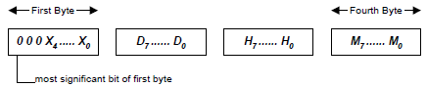

All numbers are in binary coded decimal:

X4 months, tens

X3…X0 months, units

D7…D4 days, tens

D3…D0 days, units

H7…H4 hours, tens

H3…H0 hours, units

M7…M4 minutes, tens

M3…M0 minutes, units

#### EVENT TAG FORMAT

An event tag contains the channel number, direction of transition, calendar seconds and calendar milliseconds, in the following format:

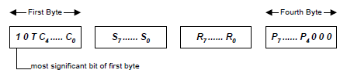

T = transitions: if T = 1, event is positive-going (low to high)

if T = 0, event is negative-going (high to low)

C4…C0 channel number in binary (C4 is most significant)

**Note:** Channel numbers entered for the 3595 2A IMP correspond exactly with the physical channels:

1 = Channel 1, 2 = Channel 2, etc. With the 3595 2B IMP however, channel numbers 0 through 31 represent the physical channels 1 through 32

All remaining numbers are in binary coded decimal:

S7…S4 seconds, tens

S3…S0 seconds, units

R4…R7 milliseconds, hundreds

R3…R0 milliseconds, tens

P7…P4 milliseconds, units

#### EVENT STATUS FORMAT

Event status information is similar to that contained in an event flag. The only difference is that the event status contains the event level instead of the event transition; all other information is the same.

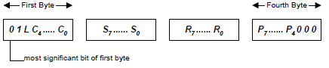

L = status level: if L = 1, status = high

if L = 0, status = low

C4…C0 channel number (in binary, C4 is most significant)

**Note:** Channel numbers entered for the 3595 2A IMP correspond exactly with the physical channels:

1 = Channel 1, 2 = Channel 2, etc. With the 3595 2B IMP however, channel numbers 0 through 31 represent the physical channels 1 through 32

All remaining numbers are in binary coded decimal:

S7…S4 seconds, tens

S3…S0 seconds, units

R4…R7 milliseconds, hundreds

R3…R0 milliseconds, tens

P7…P4 milliseconds, units

#### END TAG FORMAT

An end tag indicates the end of a set of event data. It is used when less than 112 bytes are transmitted. The format is as follows:

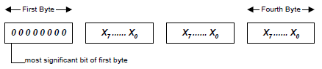

#### LOST EVENT RESULT FORMAT

The ‘lost event’ result contains the number of events lost due to the 4C Interface card input buffer being full. The format is as follows:

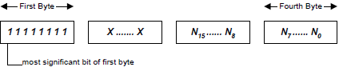

### TIME TAG FORMATS (FOR 3595 1H AND 1J IMPS)

With the result format set to *time-tag*, results from the 3595 1H and 1J IMP types are returned with a bookmark and time-tag, appended. These appear at the end of each scan and at the end of each single measurement. The formats of the bookmark and time-tag are in Sections 3.5.1 and 3.5.2.

#### BOOKMARK FORMAT

A bookmark contains the calendar month, day, hour and minute. The format is:



All numbers are in binary coded decimal:

X4 months, tens

X3…X0 months, units

D7…D4 days, tens

D3…D0 days, units

H7…H4 hours, tens

H3…H0 hours, units

M7…M4 minutes, tens

M3…M0 minutes, units

#### TIME-TAG FORMAT

The time-tag contains the calendar seconds and milliseconds, in the following format:

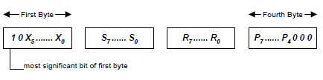

X5…X0 don’t care

All remaining numbers are in binary-coded decimal:

S7…S4 seconds, tens

S3…S0 seconds, units

R4…R7 milliseconds, hundreds

R3…R0 milliseconds, tens

P7…P4 minutes, units

### HISTORICAL DATA FORMATS (FOR 3595 1H and 1J)

With the result format set to *historical*, results from 3595 Series IMP types 1H and 1J are preceded with a *bookmark* and *time-tag*. These are described in Section 3.6.2 and 3.6.3.

In addition, to increase data throughput, and thus allow the historical buffer to be emptied quickly after a temporary loss of S-Net, the data streaming is completely reorganised. This allows up to 240 bytes of scan or single measurement data to be passed back in Stream 2 to the Host PC, for every poll. Data streaming for historical results is described in Section 3.6.1. The end of useful data in Stream 2 is defined by an *end-tag.* This is described in Section 3.6.4.

#### HISTORICAL DATA STREAM

Historical data is carried on Stream 2. This is enlarged to 240 bytes so that more than one scan, and possibly some single measurements, can be returned every poll.

After a temporary loss of S-Net, the enlarged Stream 2 allows the Host PC to extract data from the **historical data buffer** as quickly as possible. The Host PC can then get up-to-ate with real-time measurements as they are made. (Unwanted historical data may be flushed out.)

Stream 0 is not used (except in the special case of SA) and Stream 1 is not used. Stream 3 is retained; it resides at the top of the data page.

Stream 2 never splits scan result blocks across a data page. Therefore, after a loss in communications, and while extracting buffered scans, Stream 2 contains one or two full data scans (and possibly measurement results). The end of useful data is marked with and end-tag. Note that this does not imply that there is no more historical data to extract; it does imply that the last piece of useful data has been read from the data page.

#### BOOKMARK FORMAT

A bookmark contains the calendar month, day, hour and minute. The format is:



All numbers are in binary coded decimal:

X4 months, tens

X3…X0 months, units

D7…D4 days, tens

D3…D0 days, units

H7…H4 hours, tens

H3…H0 hours, units

M7…M4 minutes, tens

M3…M0 minutes, units

#### TIME TAG FORMAT

The time-tag contains an indication of whether the following data is a scan or a single measurement, the channel number, and the calendar seconds and milliseconds. It has the following format:

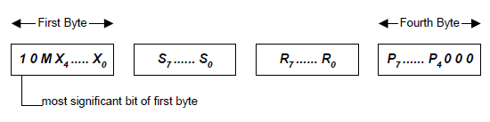

M if M = 0, a single measurement follows the time-tag

if M = 1, a scan follows the time-tag

C4…C0  channel number (in binary). Not used if M = 1 (a scan)

All remaining numbers are in binary-coded decimal:

S7…S4 seconds, tens

S3…S0 seconds, units

R4…R7 milliseconds, hundreds

R3…R0 milliseconds, tens

P7…P4 minutes, units

#### END TAG FORMAT

An *end-tag* in historical data indicates that there is no more data following it in the data page. The format is as follows:



Note that the *end-tag* does not imply that there is no more historical data to extract; it does imply that the last piece of useful data has been read from the data page.

### IMP ERROR MESSAGES

Error messages are transmitted by an IMP instead of a 4-byte result. They occur only in response to a **ME** or **TR** command.

An error message is in the form of a 4-byte analogue result with a negative sign and an exponent of 255. In hexadecimal format, this is represented by any number in excess of ‘FF800000’. In IEEE 754 floating-point format, this is equivalent to ‘Not a number’.

|  |  |
| --- | --- |
| FF81 xxxx | Analogue overload. The input to an analogue measurement channel has exceeded the maximum value of the present range. |
| FF82 xxxx | User thermocouple undefined. Returned when a channel mode is set to 39x or 3Ax, but the corresponding thermocouple has not been defined. (3595 1H and 1J only) |
| FF83 xxxx | Out of linearisation range. Returned by a thermocouple channel when the temperature is out of measurable range. |
| FF84 xxxx | Ambient temperature range. The IMP has been instructed to use a temperature reference outside the permitted range (-30oC to +80oC) |
| FF85 xxxx | Transducer error. The IMP analogue-to-digital converter is unable to decide a value. This is commonly du to an open-circuit input or a large over-voltage |
| FF86 xxxx | Open-circuit thermocouple error. Open-circuit thermocouple checking is enabled and the IMP detected a failure. |
| FF87 xxxx | Unknown mode, type or range. The IMP has been instructed to select an inapplicable channel mode or an unsupported integration time. |
| FF88 xxxx | This error code is unassigned |
| FF89 xxxx | Channel number out of range. A channel number, n, outside the permitted range, has been specified. The permitted range is 1 ≤ n ≤ 10 (for IMP type 3595 1B) or 1 ≤ n ≤ 20 (for IMP types 3595 1A, 1C, 1H, 1J and 2A). |
| FF8A xxxx | System zero error. The IMP is unable to perform a drift correction. |
| FF8B xxxx | System calibration corrupt. The calibration constants (Including backup values) held in the non-volatile memory show ‘read errors’. Non-volatile memory is either corrupted or not fitted. |
| FF8C xxxx | Strain gauge not initialised. The IMP database must be loaded with the gauge offset resistance and factor. See the ‘Command Directory’ entry for **IN**. (Relevant only to IMP type 3595 1B) |
| FF8D xxxx | Digital result pending. (Relevant only to IMP types 3595 1H and 1J) |
| FF8E xxxx | Period time-out. The IMP has tried to measure a time period but took longer than the maximum time allowed (as set by the **CH TI** command) |
| FFFF xxxx | Not measured. The channel has been set to ‘skip’, ‘digital output’ or ‘event capture’ |

The remainder of possible error codes are unassigned.

# Appendix - Upgrading Interface Firmware

The 35954U Interface allows the user to upgrade the Interface firmware. If your Interface requires an upgrade, please follow the steps below.

1. Disconnect the Interface
2. Remove and retain the 4 screws on the front panel of the unit and slide off the top cover.
3. Place a Jumper on the program link (highlighted in red below) Fig 1.1 and Fig 1.2

### Fig 1.1 Location of program link.

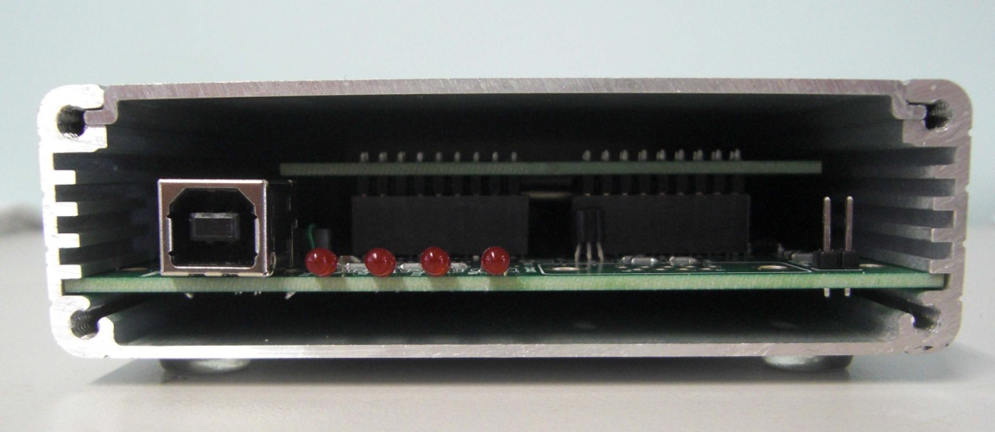

### Fig 1.2 Program link with jumper attached

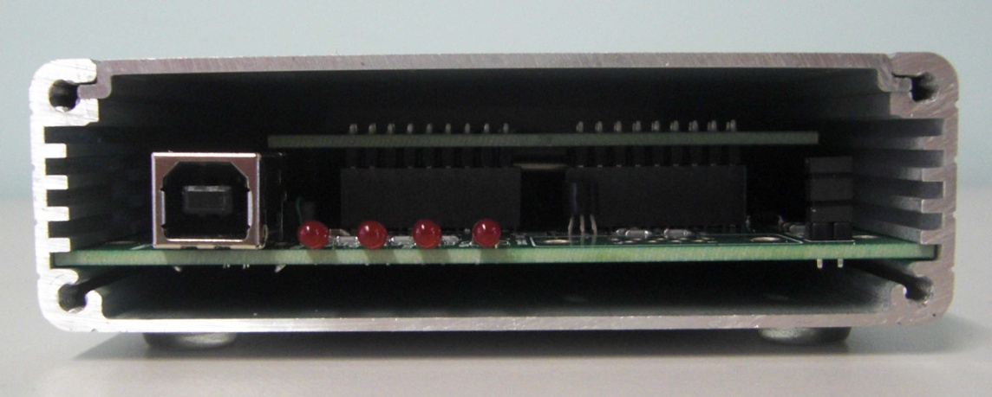

1. Connect the Interface to your PC with the USB “B” cable. There should be no LED activity when the Interface is in programming mode.
2. Download the 35954U Upgrade folder from our site. This folder contains the upgrade file and software required.
3. Install the Renesas Flash Development Toolkit which you downloaded and once complete, run the Renesas Flash Development Toolkit 4.05 Basic.
4. When the program runs, you will be asked to select your device. Navigate down the list of Interfaces and select “H8S 2398F” and click “Next”

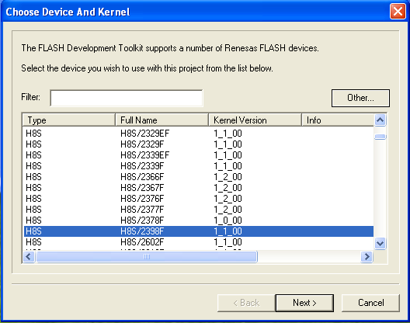

1. On the next screen, select the COM port which is associated with the Interface on your machine.
2. Now enter “14.74” as the frequency for the Interface

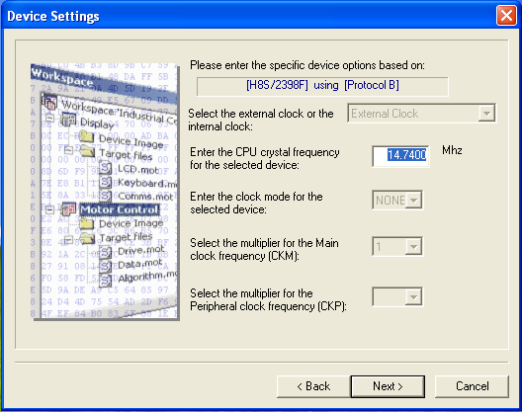

1. Next, please select “BOOT Mode” and uncheck the “Use Default” option for the recommended speed. From the drop down list, select 19200 as shown below and click Next.

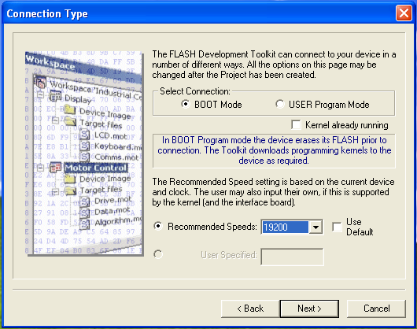

1. On the next screen, please set “Readback Verification” to “Yes” and click Finish.

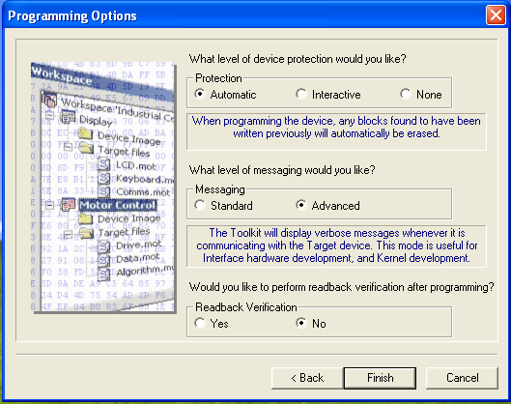

1. Now select “User/Data Area” and navigate to the 35954U.a20 file supplied in the Firmware Upgrade folder you previously downloaded.

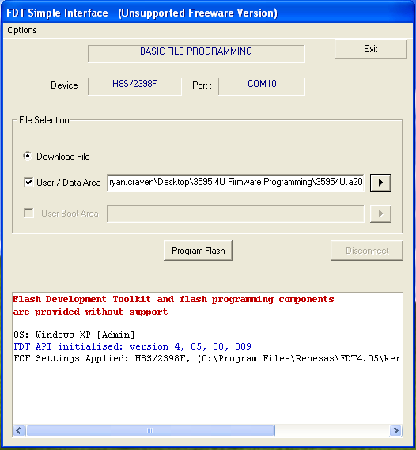

1. Click “Program Flash” and allow the upgrade to complete. The upgrade progress and any errors will appear in the status box located at the bottom of the screen.
2. Once completed, exit the program.
3. Disconnect the Interface, remove the Jumper from the program link and replace the top cover and front panel, securing with the 4 screws.
4. You can now reconnect the Interface to your machine and confirm the successful upgrade.